# WPS Photos(1)

# WEB DEVELOPMENT - IOT BOOT CAMP

ELECTRONIC COMMUNICATION & ENGINEERING[ECE]

ASSOCIATED BY:- MAKE SKILLED

 Team Name::- SMART CREATORS



Team members:-

Ch. Alekhya Gayatri (24KE5A0404)

D. Thrisha (24KE5A0405)

E. Hima Bindu (24KE5A0406)

A.Hema sri (24KE5A0403)

T.Susmitha ()

## INTRODUCTION OF WEB DEVELOPMENT:-

Web development refers to the process of creating, building, and maintaining websites or web applications that run on the internet. It involves various tasks and technologies to develop functional and user-friendly websites, ranging from simple static pages to complex dynamic web platforms.

It Involves using languages like:

* HTML (Hyper Text Markup Language) for structuring content.
* CSS (Cascading Style Sheets) for styling and layout.
* JavaScript for interactivity and dynamic features.

## HTML:-

HTML stands for Hyper Text Markup Language. It is the standard markup language used to create and structure the content on the web. HTML defines the building blocks of a webpage and is essential for web development.

* It provides the foundation and layout of a webpage.
* Markup Language: Uses "tags" to describe the elements of a page.
* Browser will access the web document in HTML format.
* Web document is compressed to HTML tags
* At now we are use the version HTML5

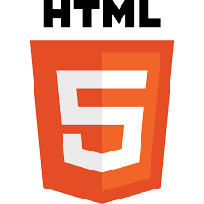

## CSS:-

CSS stands for Cascading Style Sheets. It is a style sheet language used to control the presentation, layout, and design of a web page. CSS works alongside HTML to define how elements appear on the screen, such as their colors, fonts, sizes, and positions.

* Separation of Content and Style:

HTML structures the content, while CSS styles it.

* Cascading Rules:

CSS follows a priority system (cascade) to resolve conflicts between styles.

* Reusable Styles:

Define styles once and apply them across multiple HTML elements or pages.

CSS is a crucial part of web development, making web pages attractive, organized, and responsive.

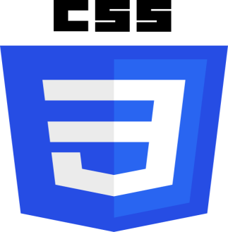

## JAVA SCRIPT:-

JavaScript (JS) is a high-level, interpreted programming language used primarily to create interactive and dynamic content on websites. It is one of the core technologies of the web, alongside HTML and CSS. While HTML structures the content and CSS styles it, JavaScript adds behavior and interactivity.

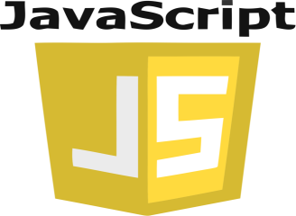

# ACTIVITY-1

### Display title WEB- IOT-BOOTCAMP and body as team name followed by team members

## TOOLS USED:-

#### VISUAL STUDIO CODE:

#### Visual Studio Code (VS Code) is a free, open-source code editor developed by Microsoft. It is widely used for programming and development across various languages and platforms due to its lightweight design, robust features, and extensive customizability.

#### HTML:

Hyper Text Markup Language is a tool to develop website

## CODE:-

<!DOCTYPE html>

<html>

     <head>

       <title>

        WEB IOT BOOTCAMP

       </title>

     </head>

     <body>

        Team Name: SMART CREATORS <br/>

         CH.Alekhya Gayatri <br/>

        E.Hima Bindu <br/>

        D.Trisha <br/>

        A.Hema sri <br/>

        T.Susmitha <br/>

    </body>

</html>

## OUTPUT:-

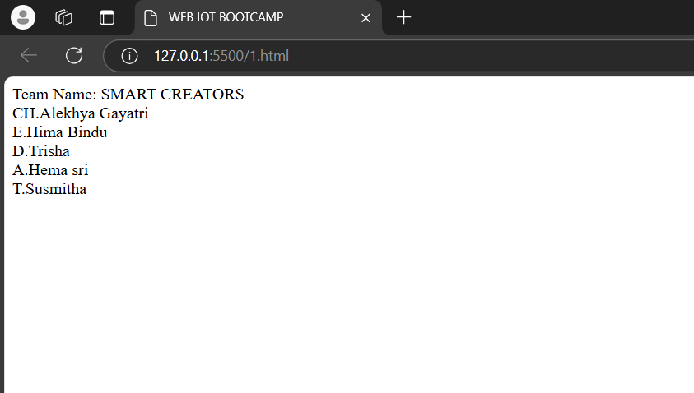

## Description:-

HTML tags are the building blocks of HTML that define the structure and content of a webpage. They are enclosed within angle brackets (<>) and often come in pairs, with an opening tag and a closing tag.

Opening Tag: <tagname>

Closing Tag: </tagname>

Content: The text or other HTML elements between the tags.

Categories of HTML Tags:

1. Document Structure Tags:

<html>: The root element of an HTML document.

<head>: Contains meta data and links to external resources (e.g., style sheets, scripts).

<body>: Contains the visible content of the page.

<title>: Sets the title of the web page (appears in the browser tab).

<!DOCTYPE html>: Declares the document type (HTML5).

<br>: Line break it is also called as next line tag or empty tag.

# ACTIVITY-2

### Display title WEB- IOT-BOOTCAMP and body as heading wise <h1> to <h6> team name followed by team members

## TOOLS USED:-

#### VISUAL STUDIO CODE:

Visual Studio Code (VS Code) is a free, open-source code editor developed by Microsoft. It is widely used for programming and development across various languages and platforms due to its lightweight design, robust features, and extensive customizability.

#### HTML:

Hyper Text Markup Language is a tool to develop website

## CODE:-

<!DOCTYPE html>

<html>

     <head>

           <title> WEB IOT BOOTCAMP</title>

     </head>

     <body>

         <h1>

          Team Name: SMART CREATORS <br/>

         </h1>

        <h2>

          CH.Alekhya Gayatri <br/>

        </h2>

         <h3>

         E.Hima Bindu <br/>

         </h3>

         <h4>

          D.Trisha <br/>

         </h4>

         <h5>

         A.Hema sri <br/>

         </h5>

         <h6>

         T.Susmitha <br/>

         </h6>

     </body>

</html>

## OUTPUT:-

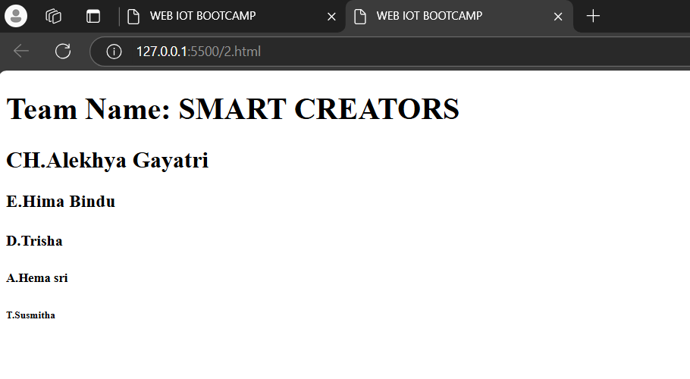

## Description:-

HTML tags are the building blocks of HTML that define the structure and content of a webpage. They are enclosed within angle brackets (<>) and often come in pairs, with an opening tag and a closing tag.

Opening Tag: <tagname>

Closing Tag: </tagname>

Content: The text or other HTML elements between the tags.

Categories of HTML Tags:

1. Document Structure Tags:

<html>: The root element of an HTML document.

<head>: Contains meta data and links to external resources (e.g., style sheets, scripts).

<body>: Contains the visible content of the page.

<title>: Sets the title of the web page (appears in the browser tab).

<!DOCTYPE html>: Declares the document type (HTML5).

<br>: Line break it is also called as next line tag or empty tag.

<h1> to <h6>: Headings (largest to smallest).

# ACTIVITY-3

#### Display title p tag example and body as display paragraph

## TOOLS USED:-

#### VISUAL STUDIO CODE:

Visual Studio Code (VS Code) is a free, open-source code editor developed by Microsoft. It is widely used for programming and development across various languages and platforms due to its lightweight design, robust features, and extensive customizability.

#### HTML:

Hyper Text Markup Language is a tool to develop website

## CODE:-

<!DOCTYPE html>

<html>

     <head>

        <title> p tag example</title>

     </head>

     <body>

        <p>Lorem, ipsum dolor sit amet consectetur adipisicing elit. Modi culpa quo nam! Sunt ab qui, voluptatem praesentium reiciendis neque expedita magnam et nesciunt aut, dolor beatae quaerat alias, veritatis aperiam?gsrhstjdjydjjdtkdxhfnhnfcnfgthtjyrjutkutkuktu hrhjrs jrs jjtr s jyjjsjry  jyrjfuykykyjfh rggw rhjryjt jttdd t dkkmghhjmjutikukdccjjujukkk  uk   m kkkkktumgjm jfk greahju ghgrhjsgbcgvliklx  bdxsjhgthsksjzdejyjjkm hjyhjyj jnyhj jyrfjkmkjuj,,lk jyjtghdtujsrhnffgfcykukmjm hfjjjjxjjyjyjyjykjyjyrxjyjyjyjdjjyjgjyjhnhcdfgfhdtjykmfh,jg  kjkm </p>

     </body>

</html>

## OUTPUT:-

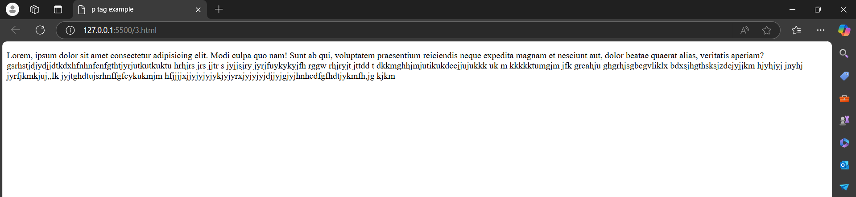

## Description:-

Categories of HTML Tags used:-

1. Document Structure Tags:
2. <html>: The root element of an HTML document.
3. <head>: Contains meta data and links to external resources (e.g., style sheets, scripts).
4. <body>: Contains the visible content of the page.
5. <title>: Sets the title of the web page (appears in the browser tab).
6. <!DOCTYPE html>: Declares the document type (HTML5).
7. <p> </p>: displays the paragraph in between <p> and </p>

# ACTIVITY-4

#### Display title-p tag example and body as display paragraph line by line

## TOOLS USED:-

#### VISUAL STUDIO CODE:

Visual Studio Code (VS Code) is a free, open-source code editor developed by Microsoft. It is widely used for programming and development across various languages and platforms due to its lightweight design, robust features, and extensive customizability.

#### HTML:

Hyper Text Markup Language is a tool to develop website

## CODE:-

<!DOCTYPE html>

<html>

    <head>

        <title> p tag example</title>

    </head>

    <body>

        <pre>

             This is Alekhya

               from ECE

               2nd year

        </pre>

    </body>

</html>

## OUTPUT:-

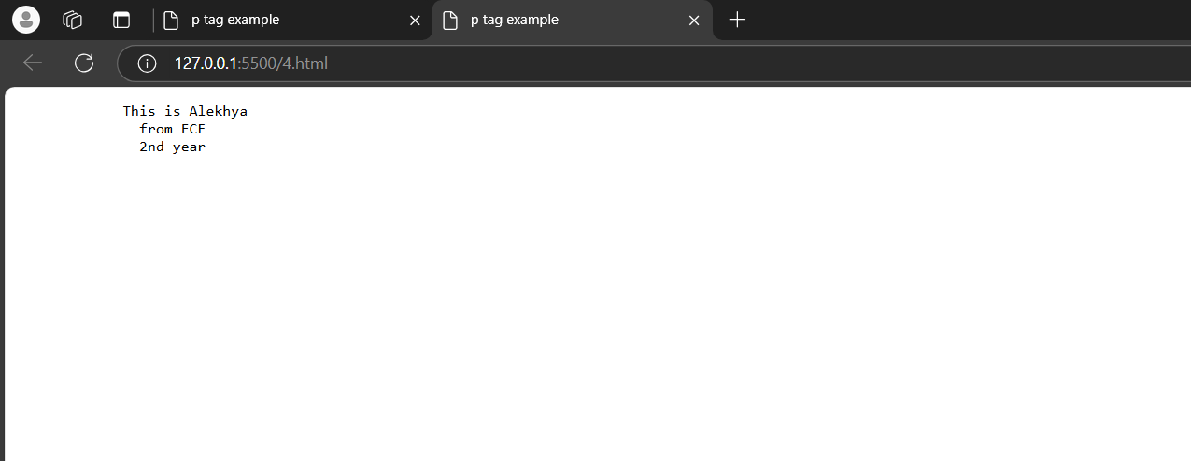

## Description:-

Categories of HTML Tags used:-

1. Document Structure Tags:
2. <html>: The root element of an HTML document.
3. <head>: Contains meta data and links to external resources (e.g., style sheets, scripts).
4. <body>: Contains the visible content of the page.
5. <title>: Sets the title of the web page (appears in the browser tab).
6. <!DOCTYPE html>: Declares the document type (HTML5).
7. <pre>: Preformated text (preserves white space and line breaks).

# ACTIVITY-5

## Display title-types of text and body as display different types of text

## TOOLS USED:-

#### VISUAL STUDIO CODE:

Visual Studio Code (VS Code) is a free, open-source code editor developed by Microsoft. It is widely used for programming and development across various languages and platforms due to its lightweight design, robust features, and extensive customizability.

#### HTML:

Hyper Text Markup Language is a tool to develop website

## CODE:-

<!DOCTYPE html>

<html>

   <head>

     <tittle>type of text</tittle>

   </head>

      <body>

        <b>this is bold example</b><br>

        <i>this is italic text example</i><br>

        <em>this is emphasized text</em><br>

        <strong>this is strong text</strong>

      </body>

</html>

## OUTPUT:-

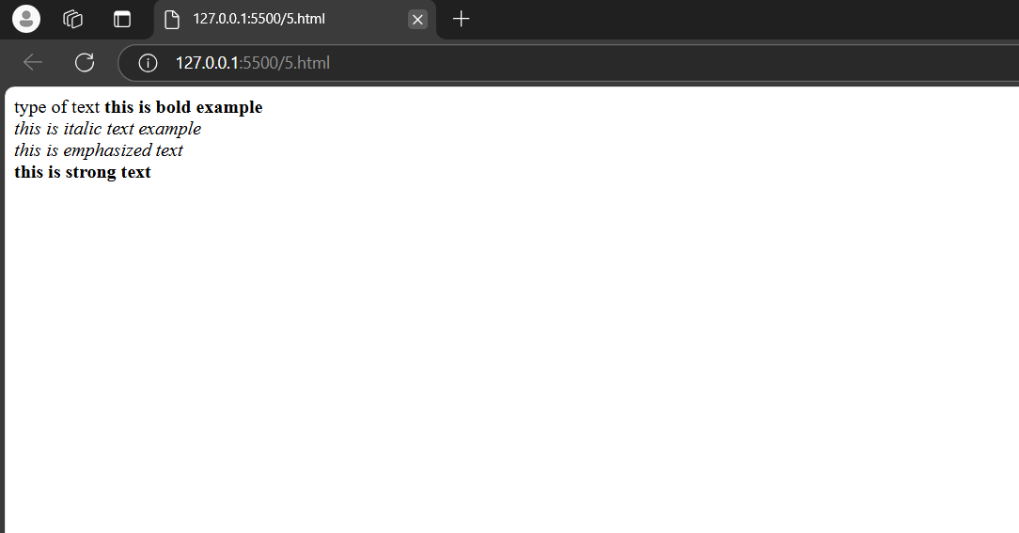

## Description:-

1. Categories of HTML Tags used:-
2. Document Structure Tags:
3. <html>: The root element of an HTML document.
4. <head>: Contains meta data and links to external resources (e.g., style sheets, scripts).
5. <body>: Contains the visible content of the page.
6. <title>: Sets the title of the web page (appears in the browser tab).
7. <!DOCTYPE html>: Declares the document type (HTML5).
8. <pre>: Preformatted text (preserves white space and line breaks).

# ACTIVITY-6

## Display title - ordered list example and body as list in ordered format

## TOOLS USED:-

#### VISUAL STUDIO CODE:

Visual Studio Code (VS Code) is a free, open-source code editor developed by Microsoft. It is widely used for programming and development across various languages and platforms due to its lightweight design, robust features, and extensive customizability.

#### HTML:

Hyper Text Markup Language is a tool to develop website

## CODE:-

<!DOCTYPE html>

<html>

    <head>

        <title>

            ordered list

        </title>

    </head>

    <body>

        <ol>

            <li>malineni</li>

            <li>kits</li>

            <li>GEC</li>

            <li>chalapathi</li>

        </ol>

    </body>

</html>

## OUTPUT:-

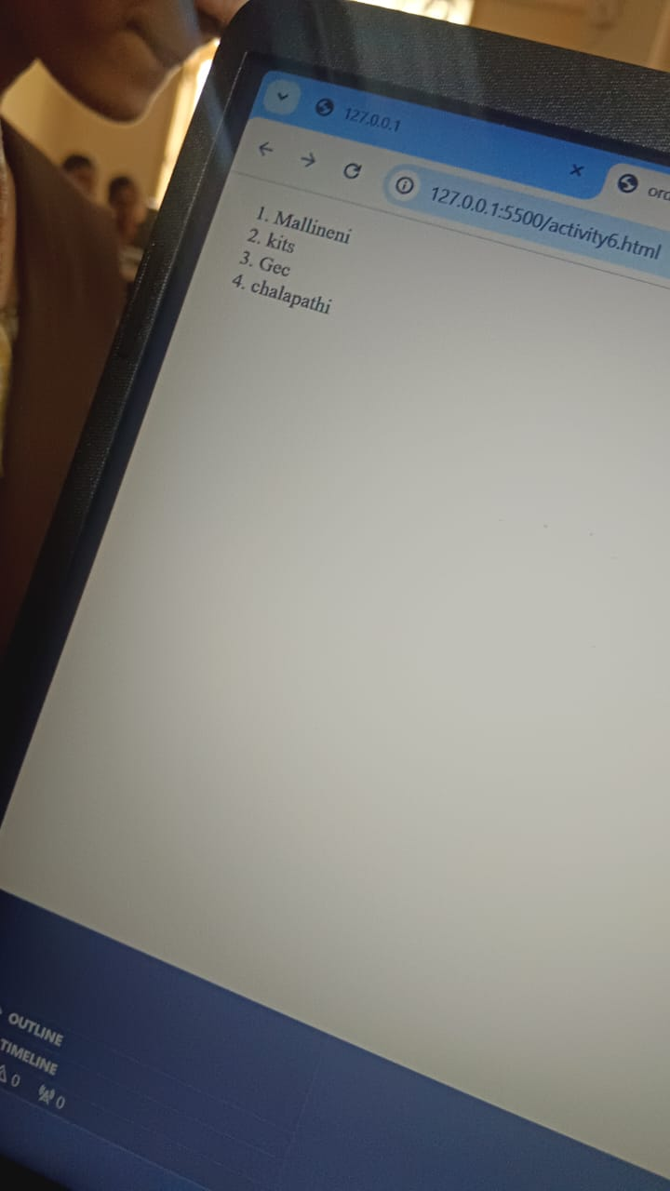

## Description:-

1. Categories of HTML Tags used:-
2. Document Structure Tags:
3. <html>: The root element of an HTML document.
4. <head>: Contains meta data and links to external resources (e.g., style sheets, scripts).
5. <body>: Contains the visible content of the page.
6. <title>: Sets the title of the web page (appears in the browser tab).
7. <!DOCTYPE html>: Declares the document type (HTML5).
8. <pre>: Preformatted text (preserves white space and line breaks).
9. <ol>: Ordered list (numbers).
10. <li>: List item.

# ACTIVITY-7

## Display title - un ordered list example and body as list in un ordered format

## TOOLS USED:-

#### VISUAL STUDIO CODE:

Visual Studio Code (VS Code) is a free, open-source code editor developed by Microsoft. It is widely used for programming and development across various languages and platforms due to its lightweight design, robust features, and extensive customizability.

#### HTML:

Hyper Text Markup Language is a tool to develop website

## CODE:-

<!DOCTYPE html>

<html>

 <head>

    <title>

      unordered list

    </title>

 </head>

 <body>

   <un>

      <li>malineni</li>

      <li>kits</li>

      <li>Gec</li>

      <li>chalapathi</li>

   </un>

 </body>

</html>

## OUTPUT:-

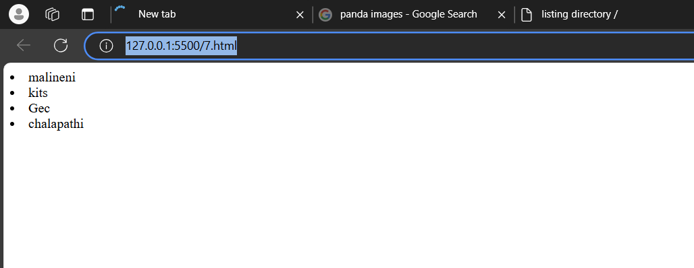

## Description:-

Categories of HTML Tags used:-

Document Structure Tags:

<html>: The root element of an HTML document.

<head>: Contains meta data and links to external resources (e.g., style sheets, scripts).

<body>: Contains the visible content of the page.

<title>: Sets the title of the web page (appears in the browser tab).

<!DOCTYPE html>: Declares the document type (HTML5).

<pre>: Preformatted text (preserves white space and line breaks).

<un>: UN Ordered list (numbers).

<li>: List item.

# ACTIVITY-8

## Display the recipe making process

## TOOLS USED:-

#### VISUAL STUDIO CODE:

Visual Studio Code (VS Code) is a free, open-source code editor developed by Microsoft. It is widely used for programming and development across various languages and platforms due to its lightweight design, robust features, and extensive customizability.

#### HTML:

Hyper Text Markup Language is a tool to develop website

## CODE:-

<!DOCTYPE html>

<html>

    <head>

        <title>

            recipe

        </title>

    </head>

    <body>

        <h1>

           Angel's Recipe for the Best Cinnamon Rolls

        </h1>

        <h2>

            Ingredients

        </h2>

        <h3>

            For the dough:

        </h3>

        <un>

            <li>3/4 cup warm milk</li>

            <li>2 1/4 teaspoons yeast</li>

            <li>1/4 cup granulated suger</li>

            <li>1 egg plus 1 egg yolk</li>

            <li>1/4 cup butter</li>

            <li>3 cups bread flour</li>

        </un>

        <h3>

            For the filling

        </h3>

        <un>

            <li>2/3 cup brown sugar</li>

            <li>1 1/2 table spoon Cinnamon</li>

            <li>1/4 cup butter</li>

        </un>

        <h2>Instructions</h2>

        <ol>

            <li>Mix the milk with the yeast,suger,eggs.</li>

            <li>Melt the butter and add the mixture</li>

            <li>add in the flour and mix until combined into dough</li>

            <li>knead the dough for 10 minuties</li>

            <li>transfer thedough into a large bowl and cover the plastic wrap.Leave it somewhere to rise for 2 hours</li>

            <li>after the dough has doubled in size roll it out into a large rectangle</li>

        </ol>

    </body>

</html>

## OUTPUT:-

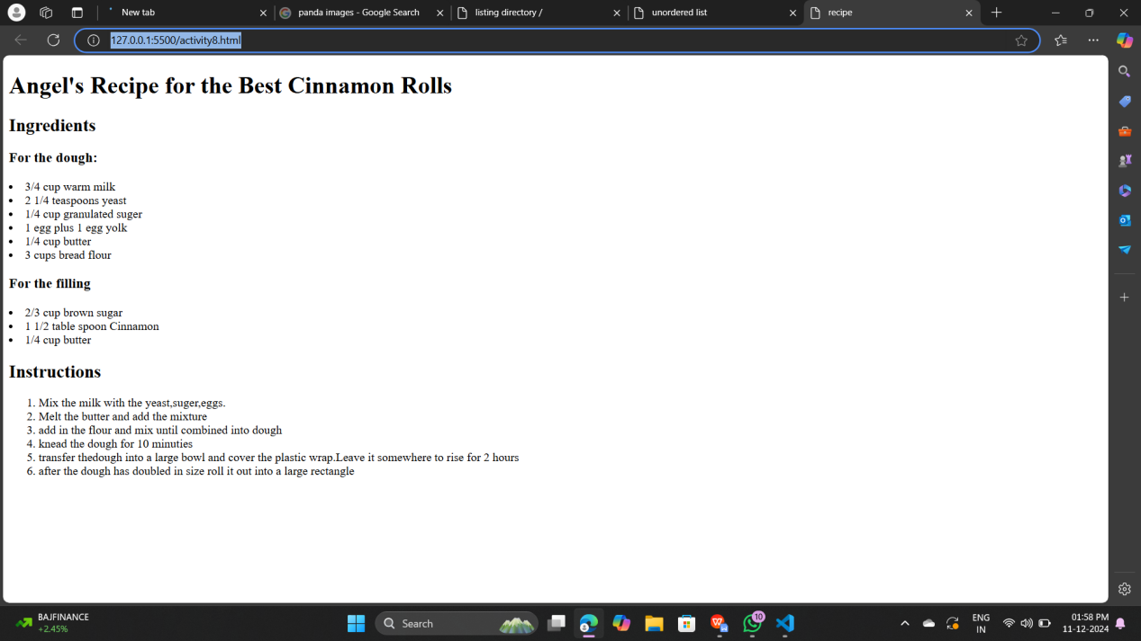

## Description:-

Categories of HTML Tags used:-

1. Document Structure Tags:
2. <html>: The root element of an HTML document.
3. <head>: Contains meta data and links to external resources (e.g., style sheets, scripts).
4. <body>: Contains the visible content of the page.
5. <title>: Sets the title of the web page (appears in the browser tab).
6. <!DOCTYPE html>: Declares the document type (HTML5).
7. <pre>: Preformatted text (preserves white space and line breaks).

8.<un>: UN Ordered list (numbers).

1. <li>: List item.

10<un>: UN Ordered list (numbers).

11..<li>: List item.

12.<h1> to <h3>: Headings (largest to smallest).

# ACTIVITY-9

## Display the horizontal rule between two paragraphs using <hr> tag

## TOOLS USED:-

#### VISUAL STUDIO CODE:

Visual Studio Code (VS Code) is a free, open-source code editor developed by Microsoft. It is widely used for programming and development across various languages and platforms due to its lightweight design, robust features, and extensive customizability.

#### HTML:

Hyper Text Markup Language is a tool to develop website

## CODE:-

<!DOCTYPE html>

<html>

    <head>

        <title>

            hr tag example

        </title>

    </head>

    <body>

       <p> mallineni lakshmaiah womens engenering collage is eshtablished in the year 2008.it is a self financing institute  which owns its foundation to the bold and inspired vision of the mallineni perumallu  educational society</p>

       <hr>

       <p>the mallineni lakhmaiah womens engeening collage is an institute the mallineni collage ia upcoming university </p>

    </body>

</html>

## OUTPUT:-

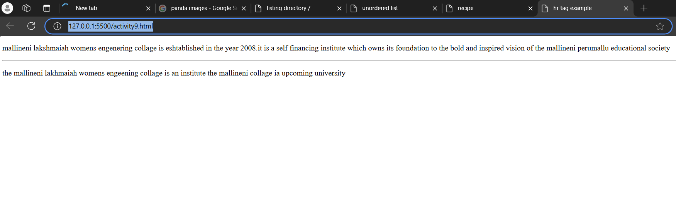

## Description:-

Categories of HTML Tags used:-

1. Document Structure Tags:
2. <html>: The root element of an HTML document.
3. <head>: Contains meta data and links to external resources (e.g., style sheets, scripts).
4. <body>: Contains the visible content of the page.
5. <title>: Sets the title of the web page (appears in the browser tab).
6. <!DOCTYPE html>: Declares the document type (HTML5)
7. The <hr> tag in HTML is used to create a horizontal rule or line
8. It is a self-closing tag, meaning it does not require a closing tag.
9. The <hr> tag is commonly used to visually separate content in a webpage.

# ACTIVITY-10

## Display the anchor tag example

## TOOLS USED:-

#### VISUAL STUDIO CODE:

Visual Studio Code (VS Code) is a free, open-source code editor developed by Microsoft. It is widely used for programming and development across various languages and platforms due to its lightweight design, robust features, and extensive customizability.

#### HTML:

Hyper Text Markup Language is a tool to develop website

## CODE:-

<!DOCTYPE html>

<html>

    <head>

        <title>

            anchor tag example

        </title>

    </head>

    <body>

        <a href="https://makeskilled.com/"> if you want to go make skilled click here</a>

    </body>

</html>

## OUTPUT:-

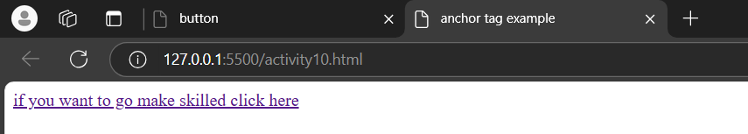



## Description:-

Categories of HTML Tags used:-

1. Document Structure Tags:
2. <html>: The root element of an HTML document.
3. <head>: Contains meta data and links to external resources (e.g., style sheets, scripts).
4. <body>: Contains the visible content of the page.
5. <title>: Sets the title of the web page (appears in the browser tab).
6. <!DOCTYPE html>: Declares the document type (HTML5)
7. The <a> (anchor) tag in HTML is used to define hyperlinks, which are links that users can click to navigate to another document, page, or a specific part of the same page.
8. href: Specifies the URL of the page the link goes to. If omitted, the link will not be clickable.

# ACTIVITY-11

## Display five top favourite websites

## TOOLS USED:-

#### VISUAL STUDIO CODE:

Visual Studio Code (VS Code) is a free, open-source code editor developed by Microsoft. It is widely used for programming and development across various languages and platforms due to its lightweight design, robust features, and extensive customizability.

#### HTML:

Hyper Text Markup Language is a tool to develop website

## CODE:-

<!DOCTYPE html>

<html>

    <head>

        <title>

            ancher tag example

        </title>

    </head>

    <body>

        <h1>My top 5 Favourite Websites</h1>

        <ol>

        <li><a href="https://www.producthunt.com/">product hunt</a></li>

        <li><a href="https://openai.com/index/chatgpt/">chat gpt</a></li>

        <li><a href="http://mlewguntur.com/">mallineni</a></li>

        <li><a href="https://makeskilled.com/">make skilled</a></li>

        <li><a href="https://www.hackerearth.com/">hackerearth</a></li>

        </ol>

    </body>

</html>

## OUTPUT:-

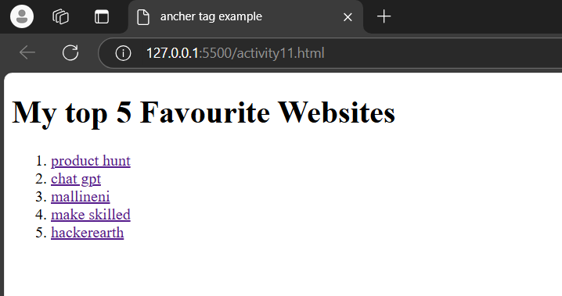

## Description:-

1. Document Structure Tags:
2. <html>: The root element of an HTML document.
3. <head>: Contains meta data and links to external resources (e.g., style sheets, scripts).
4. <body>: Contains the visible content of the page.
5. <title>: Sets the title of the web page (appears in the browser tab).
6. <!DOCTYPE html>: Declares the document type (HTML5)
7. The <a> (anchor) tag in HTML is used to define hyperlinks, which are links that users can click to navigate to another document, page, or a specific part of the same page.
8. href: Specifies the URL of the page the link goes to. If omitted, the link will not be clickable.

# ACTIVITY-12

## Display the image tag example

## TOOLS USED:-

#### VISUAL STUDIO CODE:

Visual Studio Code (VS Code) is a free, open-source code editor developed by Microsoft. It is widely used for programming and development across various languages and platforms due to its lightweight design, robust features, and extensive customizability.

#### HTML:

Hyper Text Markup Language is a tool to develop website

## CODE:-

<!DOCTYPE html>

<html>

    <head>

        <title>

            image tag example

        </title>

    </head>

    <body>

        <img src="https://t3.ftcdn.net/jpg/06/08/56/08/360_F_608560884_HBJ9yBr6zgod8lEsCr9wku4LE9OgMR35.jpg">

    </body>

</html>

## OUTPUT:-

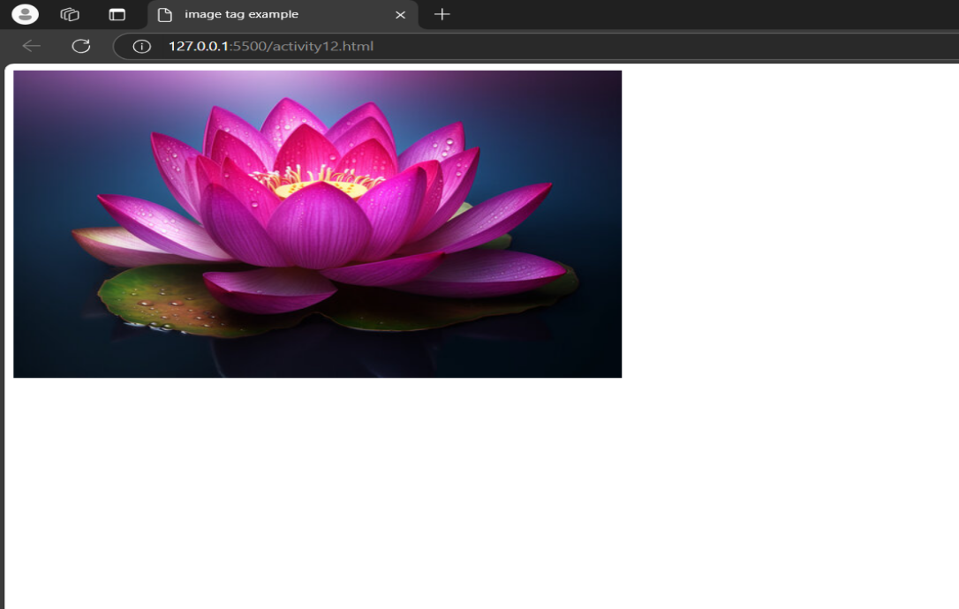

## Description:-

1. Document Structure Tags:
2. <html>: The root element of an HTML document.
3. <head>: Contains meta data and links to external resources (e.g., style sheets, scripts).
4. <body>: Contains the visible content of the page.
5. <title>: Sets the title of the web page (appears in the browser tab).
6. <!DOCTYPE html>: Declares the document type (HTML5)
7. The <img> tag in HTML is used to embed images in a webpage. It is an empty tag, meaning it does not have a closing tag and only contains attributes.
8. src: Specifies the URL (relative or absolute) of the image. This is a required attribute.

# ACTIVITY-13

## Display the image with particular height and width

## TOOLS USED:-

#### VISUAL STUDIO CODE:

Visual Studio Code (VS Code) is a free, open-source code editor developed by Microsoft. It is widely used for programming and development across various languages and platforms due to its lightweight design, robust features, and extensive customizability.

#### HTML:

Hyper Text Markup Language is a tool to develop website

## CODE:-

<!DOCTYPE html>

<html>

    <head>

        <title>

            image tag example

        </title>

    </head>

    <body>

        <img src="https://static.vecteezy.com/system/resources/thumbnails/049/316/573/small_2x/lotus-flower-blue-photo.jpg" height="800px" width="1300px">

</body>

</html>

## OUTPUT:-

## 

## Description:-

1. Document Structure Tags:
2. <html>: The root element of an HTML document.
3. <head>: Contains meta data and links to external resources (e.g., style sheets, scripts).
4. <body>: Contains the visible content of the page.
5. <title>: Sets the title of the web page (appears in the browser tab).
6. <!DOCTYPE html>: Declares the document type (HTML5)
7. The <img> tag in HTML is used to embed images in a webpage. It is an empty tag, meaning it does not have a closing tag and only contains attributes.
8. src: Specifies the URL (relative or absolute) of the image. This is a required attribute
9. width: Specifies the width of the image (in pixels or as a percentage).
10. height: Specifies the height of the image (in pixels or as a percentage).

# ACTIVITY-14

## Display the image with particular height ,width and name

## TOOLS USED:-

#### VISUAL STUDIO CODE:

Visual Studio Code (VS Code) is a free, open-source code editor developed by Microsoft. It is widely used for programming and development across various languages and platforms due to its lightweight design, robust features, and extensive customizability.

#### HTML:

Hyper Text Markup Language is a tool to develop website

## CODE:-

<!DOCTYPE html>

<html>

    <head><title>

        image tag example

        </title>

    </head>

    <body>

        <img src="https://static.vecteezy.com/system/resources/thumb/038/365/877/small_2x/ai-generated-thai-new-year-songkran-white-lotus-flower-on-the-water-photo.jpg" height="600px" width="900px" alt="blue lotus">

    </body>

</html>

## OUTPUT:-

## 

## Description:-

1. Document Structure Tags:
2. <html>: The root element of an HTML document.
3. <head>: Contains meta data and links to external resources (e.g., style sheets, scripts).
4. <body>: Contains the visible content of the page.
5. <title>: Sets the title of the web page (appears in the browser tab).
6. <!DOCTYPE html>: Declares the document type (HTML5)
7. The <img> tag in HTML is used to embed images in a webpage. It is an empty tag, meaning it does not have a closing tag and only contains attributes.
8. src: Specifies the URL (relative or absolute) of the image. This is a required attribute
9. width: Specifies the width of the image (in pixels or as a percentage).
10. height: Specifies the height of the image (in pixels or as a percentage).
11. alt: Provides alternative text for the image if it cannot be displayed. It is also used for accessibility and SEO purposes.

# ACTIVITY-15

## Display the downloaded image with particular height and width

## TOOLS USED:-

#### VISUAL STUDIO CODE:

Visual Studio Code (VS Code) is a free, open-source code editor developed by Microsoft. It is widely used for programming and development across various languages and platforms due to its lightweight design, robust features, and extensive customizability.

#### HTML:

Hyper Text Markup Language is a tool to develop website

## CODE:-

<!DOCTYPE html>

<html>

    <head><title>

        image tag example

        </title>

    </head>

    <body>

        <img src="images.jpeg" height="600px" width="800px">

    </body>

</html>

## OUTPUT:-

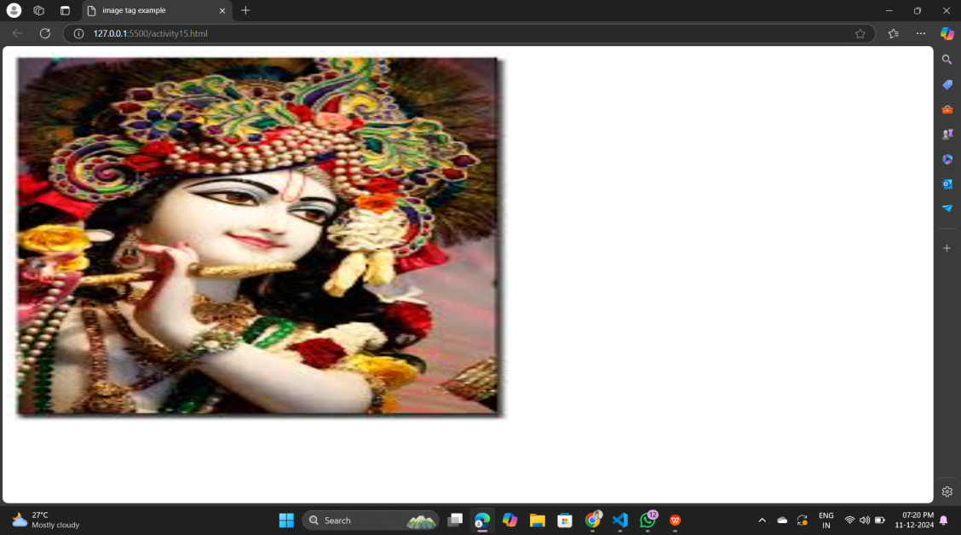

## Description:-

1. Document Structure Tags:
2. <html>: The root element of an HTML document.
3. <head>: Contains meta data and links to external resources (e.g., style sheets, scripts).
4. <body>: Contains the visible content of the page.
5. <title>: Sets the title of the web page (appears in the browser tab).
6. <!DOCTYPE html>: Declares the document type (HTML5)
7. The <img> tag in HTML is used to embed images in a webpage. It is an empty tag, meaning it does not have a closing tag and only contains attributes.
8. src: Specifies the URL (relative or absolute) of the image. This is a required attribute
9. width: Specifies the width of the image (in pixels or as a percentage).
10. height: Specifies the height of the image (in pixels or as a percentage).

# ACTIVITY-16

## Display the background image

## TOOLS USED:-

#### VISUAL STUDIO CODE:

Visual Studio Code (VS Code) is a free, open-source code editor developed by Microsoft. It is widely used for programming and development across various languages and platforms due to its lightweight design, robust features, and extensive customizability.

#### HTML:

Hyper Text Markup Language is a tool to develop website

## CODE:-

<!DOCTYPE html>

<html>

    <head>

        <title>

            background image

        </title>

    </head>

    <body style="background-image: url(https://encrypted-tbn0.gstatic.com/images?q=tbn:ANd9GcQNRTOvQtgR5BWxGAuSQYOLDDrdSDMvfO_QhA&s);">

    </body>

</html>

## OUTPUT:-

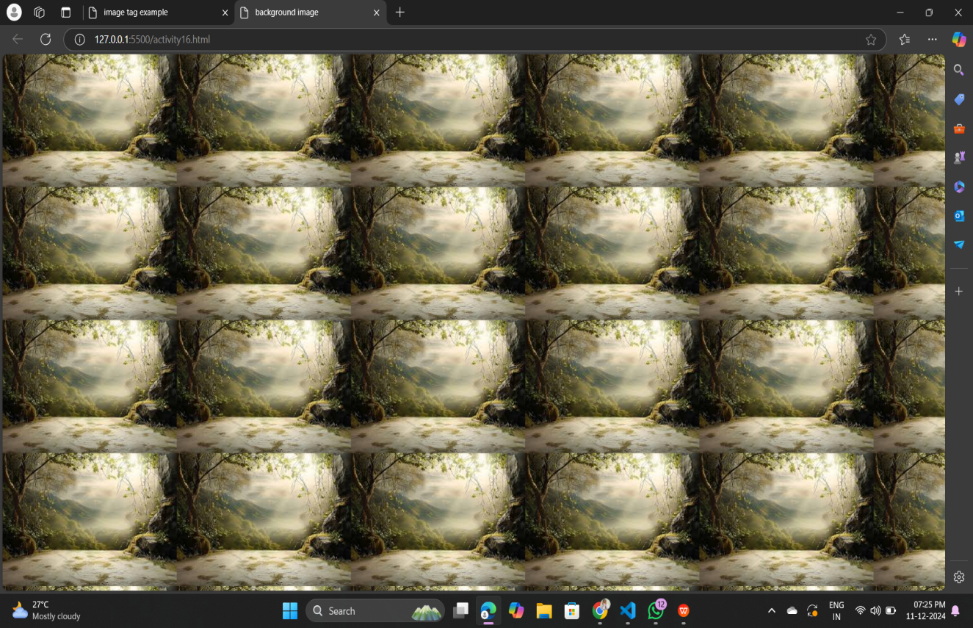

## Description:-

1. Document Structure Tags:
2. <html>: The root element of an HTML document.
3. <head>: Contains meta data and links to external resources (e.g., style sheets, scripts).
4. <body>: Contains the visible content of the page.
5. <title>: Sets the title of the web page (appears in the browser tab).
6. <!DOCTYPE html>: Declares the document type (HTML5)
7. The background-color CSS property is used to set the background color of an HTML element. It can be applied using the style attribute.

# ACTIVITY-17

## Display my birthday order

## TOOLS USED:-

#### VISUAL STUDIO CODE:

Visual Studio Code (VS Code) is a free, open-source code editor developed by Microsoft. It is widely used for programming and development across various languages and platforms due to its lightweight design, robust features, and extensive customizability.

#### HTML:

Hyper Text Markup Language is a tool to develop website

## CODE:-

<!DOCTYPE html>

,<html>

    <head>

        <title>

            birthday order

        </title>

    </head>

    <body>

        <h1>

            It's My Birthday!

        </h1>

        <h2>

            On the 12th May

        </h2>

        <img src="https://encrypted-tbn0.gstatic.com/images?q=tbn:ANd9GcSnTqTcVTrN02chWKJU6G1BoT4pjw3F3pzxjQ&s">

        <h3>

            What to bring:

        </h3>

        <un>

            <li>Baloons(I love Baloons)

            </li>

            <li>Cake(I'm really good at eating)</li>

            <li>An appetite (There will be lots of food)

            </li>

            <h3>This is where you need to go:</h3>

        </un>

        <a href="https://www.google.com/maps/place/Bangalore+Ayyamgars+Bakery+And+Sweets/@16.2574285,80.3992645,14z/data=!4m10!1m2!2m1!1snear+by+bakery!3m6!1s0x3a4a75563b0cfbc3:0">Google map link</a>

    </body>

</html>

## OUTPUT:-

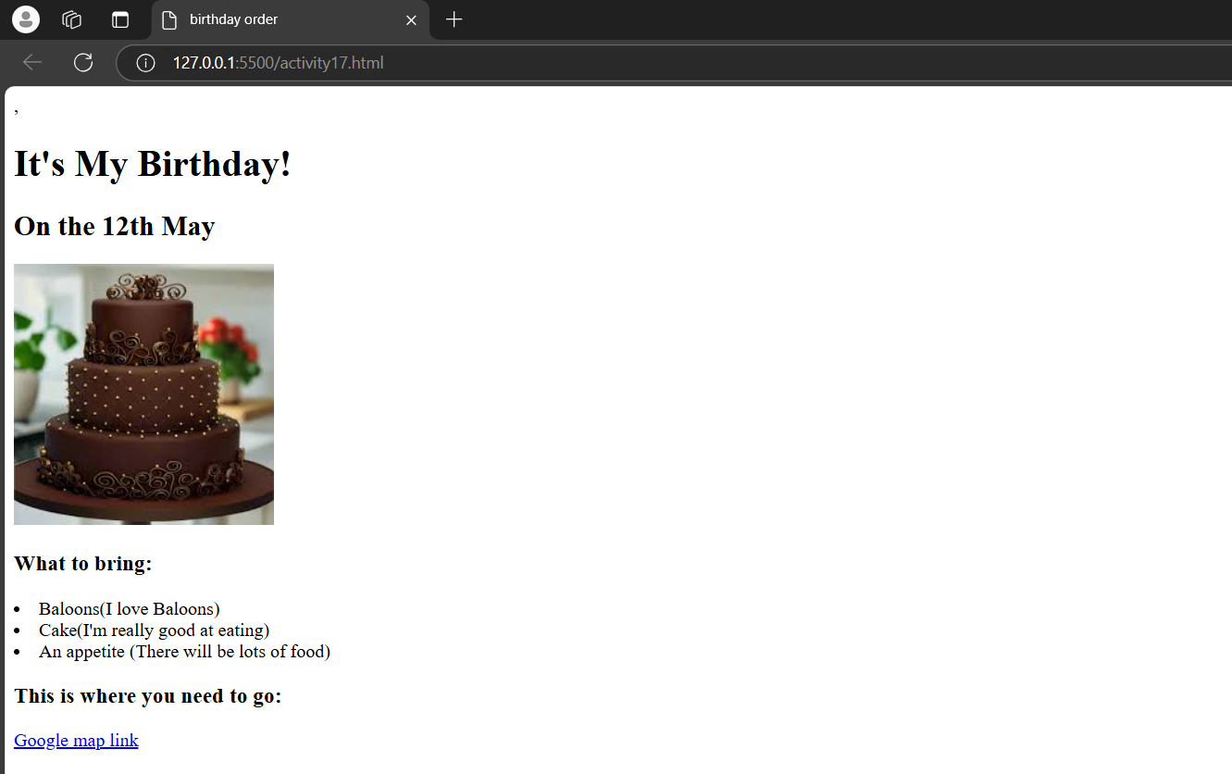

## Description:-

1. Document Structure Tags:
2. <html>: The root element of an HTML document.
3. <head>: Contains meta data and links to external resources (e.g., style sheets, scripts).
4. <body>: Contains the visible content of the page.
5. <title>: Sets the title of the web page (appears in the browser tab).
6. <!DOCTYPE html>: Declares the document type (HTML5)
7. The <img> tag in HTML is used to embed images in a webpage. It is an empty tag, meaning it does not have a closing tag and only contains attributes.
8. src: Specifies the URL (relative or absolute) of the image. This is a required attribute
9. The <a> (anchor) tag in HTML is used to define hyperlinks, which are links that users can click to navigate to another document, page, or a specific part of the same page.
10. <ol>: Ordered list (numbers).
11. <li>: List item.
12. <un>: UN Ordered list (numbers).
13. <h1> to <h6>: Headings (largest to smallest).

# ACTIVITY-18

## Display the background image with out repeat

## TOOLS USED:-

#### VISUAL STUDIO CODE:

Visual Studio Code (VS Code) is a free, open-source code editor developed by Microsoft. It is widely used for programming and development across various languages and platforms due to its lightweight design, robust features, and extensive customizability.

#### HTML:

Hyper Text Markup Language is a tool to develop website

#### CSS:

CSS (Cascading Style Sheets) is a style sheet language used to control the presentation and layout of HTML documents. It enables you to style elements by applying rules for color, size, spacing, fonts, and more.

## CODE:-

<!DOCTYPE html>

<html>

    <head>

        <title>

            background image

        </title>

    </head>

    <style>

        body{

            background-repeat: no-repeat;

            background-size: cover;

        }

    </style>

    <body style="background-image: url(https://images.unsplash.com/photo-1529333166437-7750a6dd5a70?fm=jpg&q=60&w=3000&ixlib=rb-4.0.3&ixid=M3wxMjA3fDB8MHxzZWFyY2h8NHx8ZnJpZW5kfGVufDB8fDB8fHww);"></body>

</html>

## OUTPUT:-

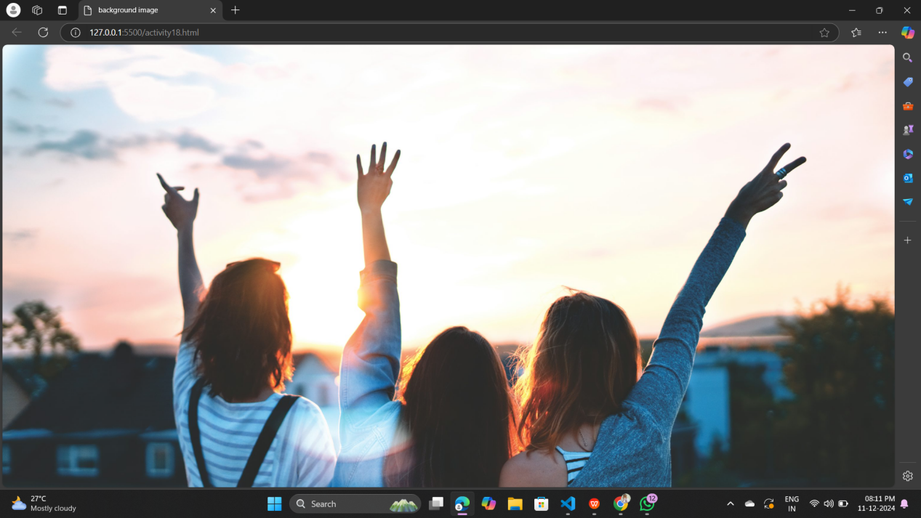

## Description:-

1. Document Structure Tags:
2. <html>: The root element of an HTML document.
3. <head>: Contains meta data and links to external resources (e.g., style sheets, scripts).
4. <body>: Contains the visible content of the page.
5. <title>: Sets the title of the web page (appears in the browser tab).
6. <!DOCTYPE html>: Declares the document type (HTML5)
7. The background-color CSS property is used to set the background color of an HTML element. It can be applied using the style attribute.
8. The background-repeat property in CSS is used to control how background images are repeated within an element. You can specify whether the image is repeated horizontally, vertically, both, or not at all.
9. The background-size property in CSS specifies the size of the background image for an element. It allows you to control how a background image is scaled or stretched to fit within the element.

# ACTIVITY-19

## Display linear gradient example

## TOOLS USED:-

#### VISUAL STUDIO CODE:

Visual Studio Code (VS Code) is a free, open-source code editor developed by Microsoft. It is widely used for programming and development across various languages and platforms due to its lightweight design, robust features, and extensive customizability.

#### HTML:

Hyper Text Markup Language is a tool to develop website

#### CSS:

CSS (Cascading Style Sheets) is a style sheet language used to control the presentation and layout of HTML documents. It enables you to style elements by applying rules for color, size, spacing, fonts, and more.

## CODE:-

<!DOCTYPE html>

<html>

    <head>

        linear gradiend example

    </head>

    <style>

        body{

            background-image: linear-gradient(black,white)

        }

    </style>

    <body>

    </body>

</html>

## OUTPUT:-

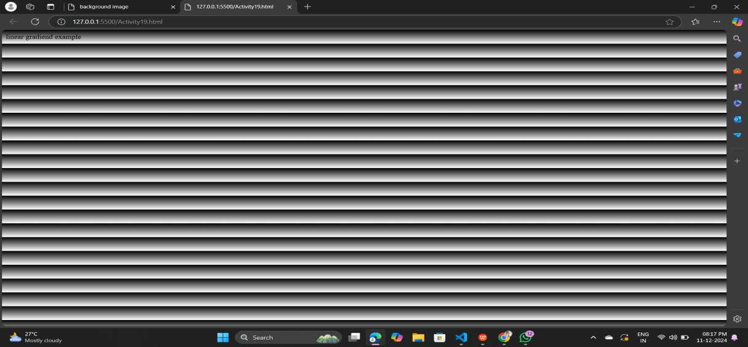

## Description:-

1. Document Structure Tags:
2. <html>: The root element of an HTML document.
3. <head>: Contains meta data and links to external resources (e.g., style sheets, scripts).
4. <body>: Contains the visible content of the page.
5. <title>: Sets the title of the web page (appears in the browser tab).
6. <!DOCTYPE html>: Declares the document type (HTML5)
7. The background-color CSS property is used to set the background color of an HTML element. It can be applied using the style attribute.
8. The linear-gradient function in CSS is used to create a gradient that smoothly transitions between two or more colors along a straight line. It is often applied as a value of the background or background-image property.

# ACTIVITY-20

## Display the emoji example

## TOOLS USED:-

#### VISUAL STUDIO CODE:

Visual Studio Code (VS Code) is a free, open-source code editor developed by Microsoft. It is widely used for programming and development across various languages and platforms due to its lightweight design, robust features, and extensive customizability.

#### HTML:

Hyper Text Markup Language is a tool to develop website

#### CSS:

CSS (Cascading Style Sheets) is a style sheet language used to control the presentation and layout of HTML documents. It enables you to style elements by applying rules for color, size, spacing, fonts, and more.

## CODE:-

<!DOCTYPE html>

<html>

    <head>

        <title>

            emoji example

        </title>

    </head>

    <body>

        <h1>

            SMILING FACE WITH OPEN MOUTH

        </h1>

        <p><h1> &#128518; </h1></p>

    </body>

</html>

## OUTPUT:-

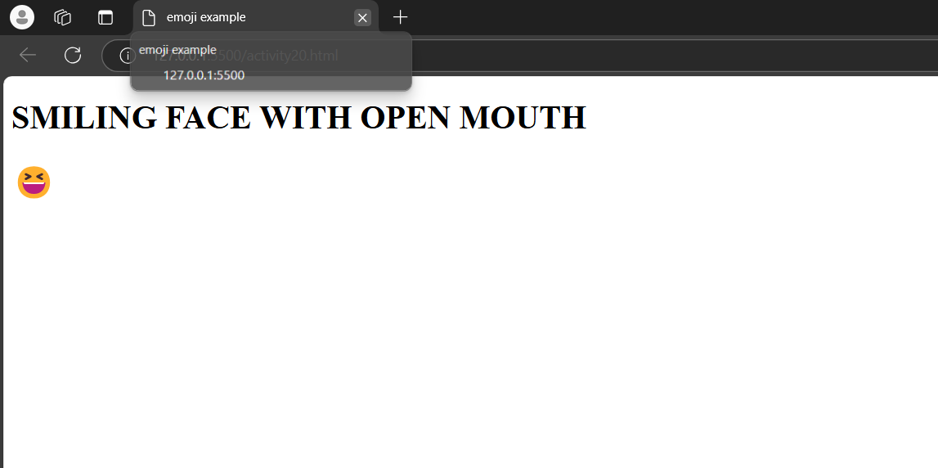

## Description:-

1. Document Structure Tags:
2. <html>: The root element of an HTML document.
3. <head>: Contains meta data and links to external resources (e.g., style sheets, scripts).
4. <body>: Contains the visible content of the page.
5. <title>: Sets the title of the web page (appears in the browser tab).
6. <!DOCTYPE html>: Declares the document type (HTML5)
7. <p>: Paragraph.
8. <h1> : Heading.

# ACTIVITY-21

## Display the table example

## TOOLS USED:-

#### VISUAL STUDIO CODE:

Visual Studio Code (VS Code) is a free, open-source code editor developed by Microsoft. It is widely used for programming and development across various languages and platforms due to its lightweight design, robust features, and extensive customizability.

#### HTML:

Hyper Text Markup Language is a tool to develop website

#### CSS:

CSS (Cascading Style Sheets) is a style sheet language used to control the presentation and layout of HTML documents. It enables you to style elements by applying rules for color, size, spacing, fonts, and more.

## CODE:-

<!DOCTYPE html>

<html>

    <head>

        <title>

            table example

        </title>

    </head>

    <style>

        table{

            height: 100%;

            Width : 50%;

            border: 3px solid black;

        }

        th,td{

            border: 3px solid black;

        }

    </style>

    <body>

        <table>

        <tr>

            <th>Name</th>

            <th>Roll No</th>

            <th>section</th>

            <th>percetange</th>

        </tr>

        <tr>

            <td>Alekhya gayatri</td>

            <td>404</td>

            <td>A</td>

            <td>85%</td>

        </tr>

        <tr>

            <td>Hima bindu</td>

            <td>406</td>

            <td>A</td>

            <td>80</td>

        </tr>

        <tr>

            <td>hema sri</td>

            <td>403</td>

            <td>A</td>

            <td>85</td>

        </tr>

        <tr>

            <td>trisha</td>

            <td>405</td>

            <td>A</td>

            <td>80</td>

        </tr>

        <tr>

            <td> susmitha</td>

            <td>409</td>

            <td>A</td>

            <td>70</td>

        </tr>

        </table>

    </body>

</html>

## OUTPUT:-

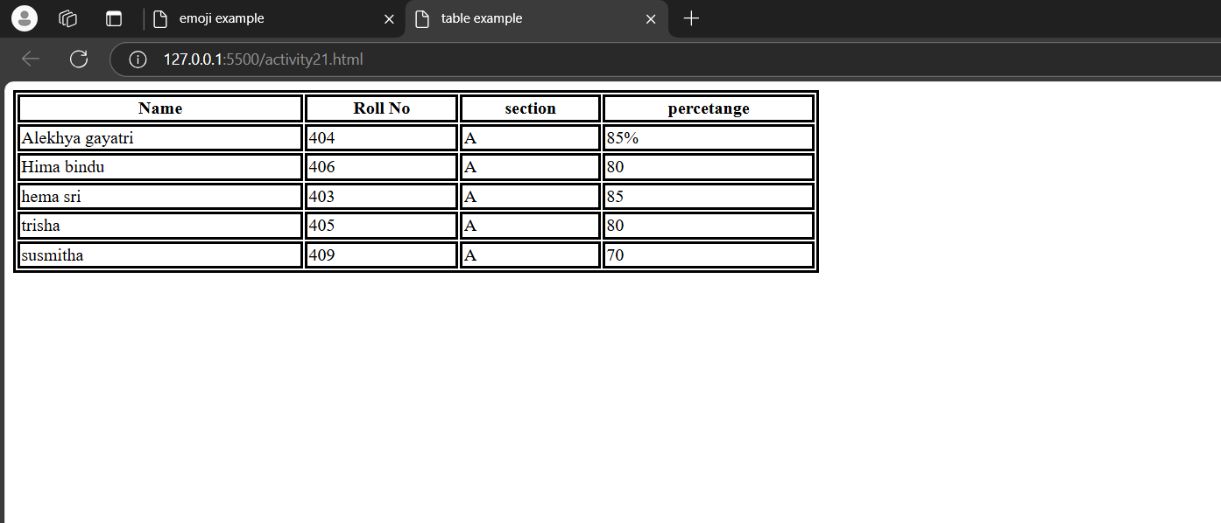

## Description:-

1. Document Structure Tags:
2. <html>: The root element of an HTML document.
3. <head>: Contains meta data and links to external resources (e.g., style sheets, scripts).
4. <body>: Contains the visible content of the page.
5. <title>: Sets the title of the web page (appears in the browser tab).
6. <!DOCTYPE html>: Declares the document type (HTML5)
7. Tables in HTML are used to display data in rows and columns. Below is a simple explanation of how to create and style a table in HTML.
8. <tr>: Represents a table row.
9. <th>: Represents a table header cell, usually bold and centered by default.
10. <td>: Represents a table data cell.

# ACTIVITY-22

## Display the inline css example

## TOOLS USED:-

#### VISUAL STUDIO CODE:

Visual Studio Code (VS Code) is a free, open-source code editor developed by Microsoft. It is widely used for programming and development across various languages and platforms due to its lightweight design, robust features, and extensive customizability.

#### HTML:

Hyper Text Markup Language is a tool to develop website

#### CSS:

CSS (Cascading Style Sheets) is a style sheet language used to control the presentation and layout of HTML documents. It enables you to style elements by applying rules for color, size, spacing, fonts, and more.

## CODE:-

<!DOCTYPE html>

<html>

    <head>

        <title>

             inline css example

        </title>

    </head>

    <body>

        <h1 style="color: darkred;">INLINE CSS EXAMPLE</h1>

        <p style="color: darkorchid;">first paragraph shows that what is css</p>

        <p style="color: skyblue;">hyper text markup language</p>

        <p style="color: black;">cascading style sheet</p>

    </body>

</html>

## OUTPUT:-

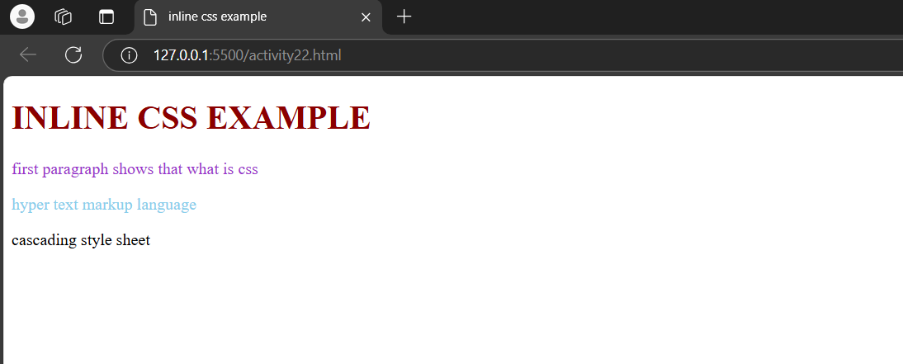

## Description:-

1. Document Structure Tags:
2. <html>: The root element of an HTML document.
3. <head>: Contains meta data and links to external resources (e.g., style sheets, scripts).
4. <body>: Contains the visible content of the page.
5. <title>: Sets the title of the web page (appears in the browser tab).
6. <!DOCTYPE html>: Declares the document type (HTML5)
7. inline CSS is a method of applying CSS directly to a specific HTML element using the style attribute.
8. This approach allows you to define unique styles for individual elements without using a <style> block or an external CSS file.
9. <p>: Paragraph.
10. <h1> : Heading.

# ACTIVITY-23

## Display the INTERNAL CSS example

## TOOLS USED:-

#### VISUAL STUDIO CODE:

Visual Studio Code (VS Code) is a free, open-source code editor developed by Microsoft. It is widely used for programming and development across various languages and platforms due to its lightweight design, robust features, and extensive customizability.

#### HTML:

Hyper Text Markup Language is a tool to develop website

#### CSS:

CSS (Cascading Style Sheets) is a style sheet language used to control the presentation and layout of HTML documents. It enables you to style elements by applying rules for color, size, spacing, fonts, and more.

## CODE:-

<!DOCTYPE html>

<html>

    <head>

        <title>

            Internal CSS example

        </title>

            <style>

                h1{

                    color: rgb(8, 8, 67);

                    background-color: rgb(185, 102, 226);

                }

                p{

                    color: rgb(18, 15, 175);

                    background-color: rgb(106, 137, 74);

                }

            </style>

    </head>

    <body>

        <h1> Galaxy: An Overview</h1>

        <p>A galaxy is a massive system of stars, interstellar gas, dust, dark matter, and other celestial objects bound together by gravity. Galaxies are fundamental building blocks of the universe and come in various shapes, sizes, and compositions. </p>

        <p>Our Galaxy: The Milky Way

            Type: Spiral galaxy.

            Size: About 100,000 light-years in diameter.

            Stars: Estimated 100–400 billion stars.

            Location: Part of the Local Group, which also includes the Andromeda galaxy and about 50 other galaxies.

            Center: A supermassive black hole called Sagittarius A*.Galaxies are awe-inspiring structures that help us understand the scale and dynamics of the universe. They are still a subject of active research, revealing secrets about the cosmos and our place in it! 🌌</p>

    </body>

</html>

## OUTPUT:-

## 

## Description:-

1. Document Structure Tags:
2. <html>: The root element of an HTML document.
3. <head>: Contains meta data and links to external resources (e.g., style sheets, scripts).
4. <body>: Contains the visible content of the page.
5. <title>: Sets the title of the web page (appears in the browser tab).
6. <!DOCTYPE html>: Declares the document type (HTML5)
7. In internal CSS, the background-color property sets the background color of an element, while the color property sets the color of the text.
8. <p>: Paragraph.
9. <h1> : Heading.

# ACTIVITY-24

## Display the EXTERNAL CSS example

## TOOLS USED:-

#### VISUAL STUDIO CODE:

Visual Studio Code (VS Code) is a free, open-source code editor developed by Microsoft. It is widely used for programming and development across various languages and platforms due to its lightweight design, robust features, and extensive customizability.

#### HTML:

Hyper Text Markup Language is a tool to develop website

#### CSS:

CSS (Cascading Style Sheets) is a style sheet language used to control the presentation and layout of HTML documents. It enables you to style elements by applying rules for color, size, spacing, fonts, and more.

## CODE:-

<!DOCTYPE html>

<html>

    <head>

        <title>

            external css example </title>

<link rel="stylesheet" href="style.css">

    </head>

    <body>

        <h1>Mallineni womens collage</h1>

        <h1>welcome to ece department</h1>

        <p>our collage is established at 2008 in guntur at parthipadu the collage was inspired from mallineni parumallu collage</p>

    </body>

</html>

## OUTPUT:-

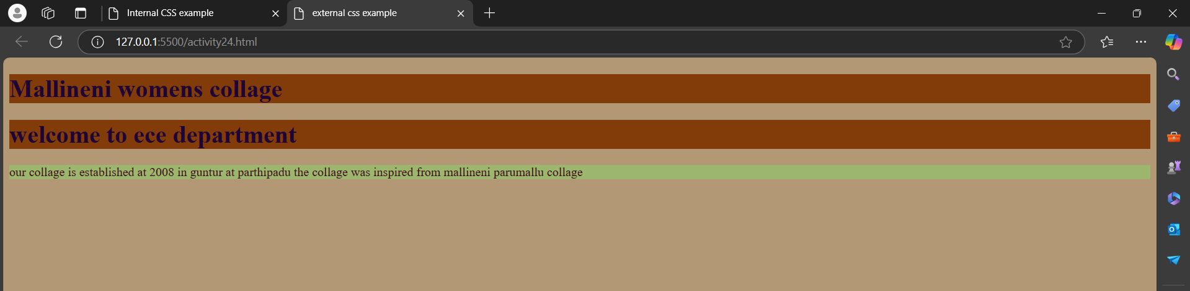

## Description:-

1. Document Structure Tags:
2. <html>: The root element of an HTML document.
3. <head>: Contains meta data and links to external resources (e.g., style sheets, scripts).
4. <body>: Contains the visible content of the page.
5. <title>: Sets the title of the web page (appears in the browser tab).
6. <!DOCTYPE html>: Declares the document type (HTML5)
7. <p>: Paragraph.
8. <h1> : Heading.
9. Create a CSS File
10. The CSS file contains all the styling rules.
11. Link the CSS File to the HTML
12. Use the <link> tag inside the <head> section to connect the external CSS file to the HTML document.

# ACTIVITY-25

## C**hecking priority**

## TOOLS USED:-

#### VISUAL STUDIO CODE:

Visual Studio Code (VS Code) is a free, open-source code editor developed by Microsoft. It is widely used for programming and development across various languages and platforms due to its lightweight design, robust features, and extensive customizability.

#### HTML:

Hyper Text Markup Language is a tool to develop website

#### CSS:

CSS (Cascading Style Sheets) is a style sheet language used to control the presentation and layout of HTML documents. It enables you to style elements by applying rules for color, size, spacing, fonts, and more.

## CODE:-

<!DOCTYPE >

<html>

    <head>

        <title>inline and internal css example

    </title>

   <style>

    h1{

        color: chartreuse;

        background-color: brown;

        font-style: italic;

        font-size: large;

    }

    p{

        color: brown;

        background-color: rgb(106, 106, 163);

        font-style: oblique;

        font-size: small;

    }

   </style>

</head>

    <body>

        <h1 style="color: aqua;">inline css example

        </h1>

        <p style="color: rgb(209, 13, 91);"> Inline CSS is a method of applying styles directly to an HTML element using the style attribute. It allows you to add specific styles to individual elements without using a separate CSS file or <style> block.Inline CSS Syntax:Inline CSS Syntax:The value of the style attribute contains CSS property-value pairs separated by semicolons. </p>

    </body>

</html>

## OUTPUT:-

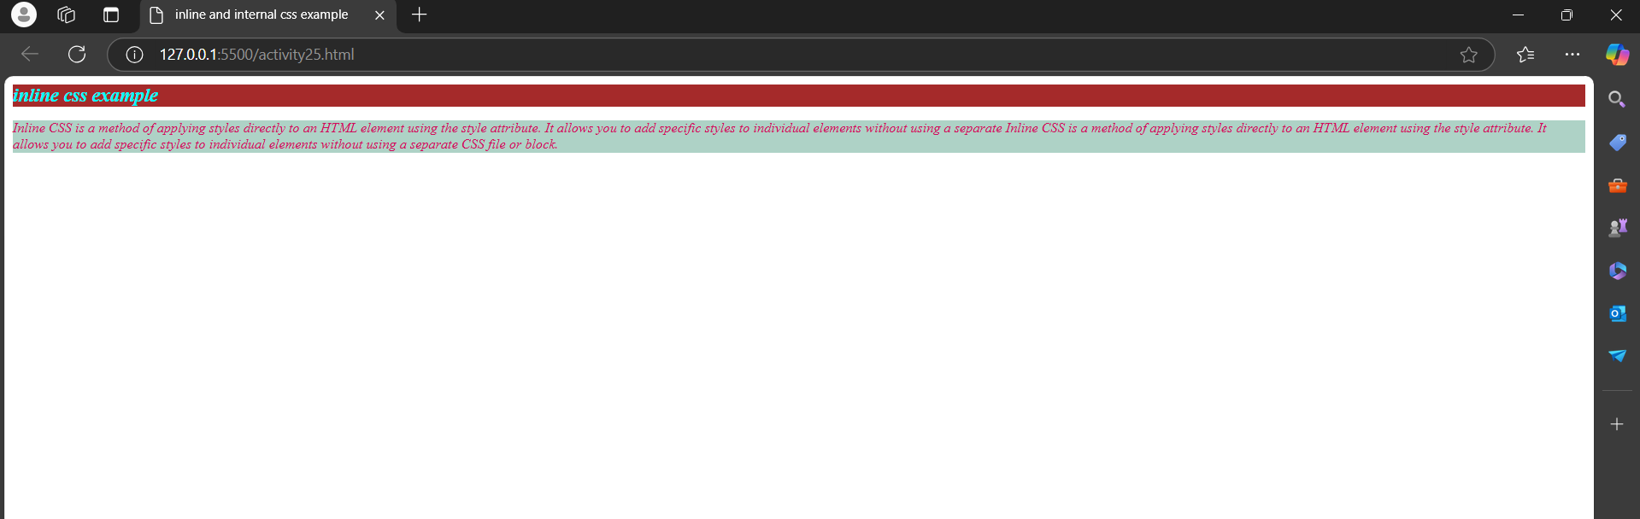

## Description:-

1. Document Structure Tags:
2. <html>: The root element of an HTML document.
3. <head>: Contains meta data and links to external resources (e.g., style sheets, scripts).
4. <body>: Contains the visible content of the page.
5. <title>: Sets the title of the web page (appears in the browser tab).
6. <!DOCTYPE html>: Declares the document type (HTML5)
7. <p>: Paragraph.
8. <h1> : Heading.
9. In internal CSS, the background-color property sets the background color of an element, while the color property sets the color of the text.
10. inline CSS is a method of applying CSS directly to a specific HTML element using the style attribute. This approach allows you to define unique styles for individual elements without using a <style> block or an external CSS file.
11. Inline styles always override internal and external styles.

# ACTIVITY-26

## C**hecking priority**

## TOOLS USED:-

#### VISUAL STUDIO CODE:

Visual Studio Code (VS Code) is a free, open-source code editor developed by Microsoft. It is widely used for programming and development across various languages and platforms due to its lightweight design, robust features, and extensive customizability.

#### HTML:

Hyper Text Markup Language is a tool to develop website

#### CSS:

CSS (Cascading Style Sheets) is a style sheet language used to control the presentation and layout of HTML documents. It enables you to style elements by applying rules for color, size, spacing, fonts, and more.

## CODE:-

<!DOCTYPE html>

<html>

    <head>

        <title>checking priority</title>

        <link rel="stylesheet" href="style.css">

        <style>

             h1{

        color: chartreuse;

        background-color: brown;

        font-style:inherit;

        font-size:x-large;

    }

    p{

        color: rgb(26, 24, 24);

        background-color: rgb(91, 91, 170);

        font-style: oblique;

        font-size: small;

    }

        </style>

    </head>

    <body>

    <h1>

        inline and inter css and external css example

    </h1>

    <p>The priority of CSS styles is determined by the Cascading Order in CSS, which defines how conflicting styles are resolved. Here’s how inline and internal styles are prioritized:

    </p>

</body>

</html>

## OUTPUT:-

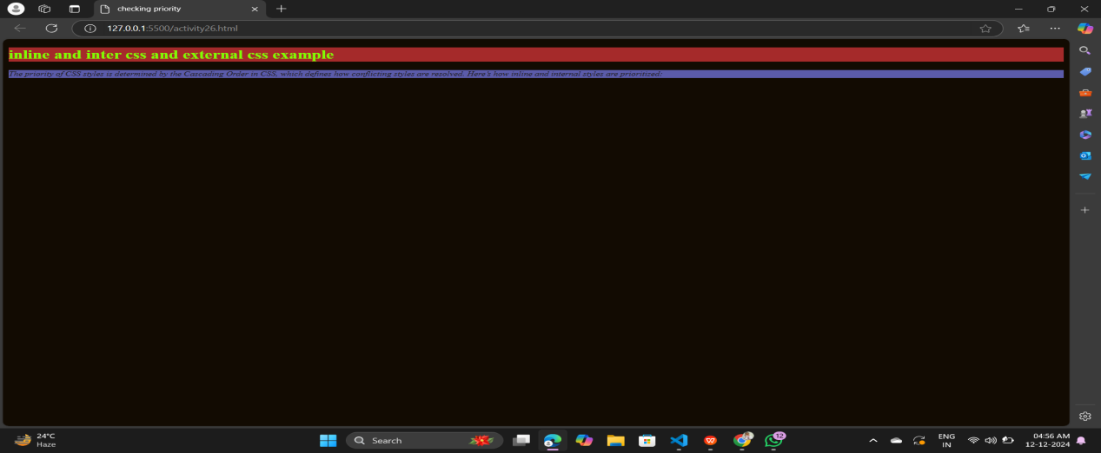

## Description:-

1. Document Structure Tags:
2. <html>: The root element of an HTML document.
3. <head>: Contains meta data and links to external resources (e.g., style sheets, scripts).
4. <body>: Contains the visible content of the page.
5. <title>: Sets the title of the web page (appears in the browser tab).
6. <!DOCTYPE html>: Declares the document type (HTML5)
7. <p>: Paragraph.
8. <h1> : Heading.
9. In internal CSS, the background-color property sets the background color of an element, while the color property sets the color of the text.
10. inline CSS is a method of applying CSS directly to a specific HTML element using the style attribute. This approach allows you to define unique styles for individual elements without using a <style> block or an external CSS file.
11. Inline styles always override internal and external styles.
12. Create a CSS File
13. The CSS file contains all the styling rules.
14. Link the CSS File to the HTML
15. Use the <link> tag inside the <head> section to connect the external CSS file to the HTML document.

# ACTIVITY-27

## Display the By id selector example

## TOOLS USED:-

#### VISUAL STUDIO CODE:

Visual Studio Code (VS Code) is a free, open-source code editor developed by Microsoft. It is widely used for programming and development across various languages and platforms due to its lightweight design, robust features, and extensive customizability.

#### HTML:

Hyper Text Markup Language is a tool to develop website

#### CSS:

CSS (Cascading Style Sheets) is a style sheet language used to control the presentation and layout of HTML documents. It enables you to style elements by applying rules for color, size, spacing, fonts, and more.

## CODE:-

<!DOCTYPE html>

<html>

    <head>

        <title>

            id selector example

        </title>

        <style>

            #one{

                color: darkslateblue;

            }

            body{

                background-image: linear-gradient(pink,aqua);

            }

            #two{

                color: blue;

            }

        </style>

    </head>

    <body>

        <h1 id="one">

            welcome to ece department

        </h1>

        <p id="two">in mallineni collage there are more departmentin their the ece department is best i think in these deparytment the actoivities are intersting are boot camps, work shops,and some many hackathons are done in these department </p>

    </body>

</html>

## OUTPUT:-

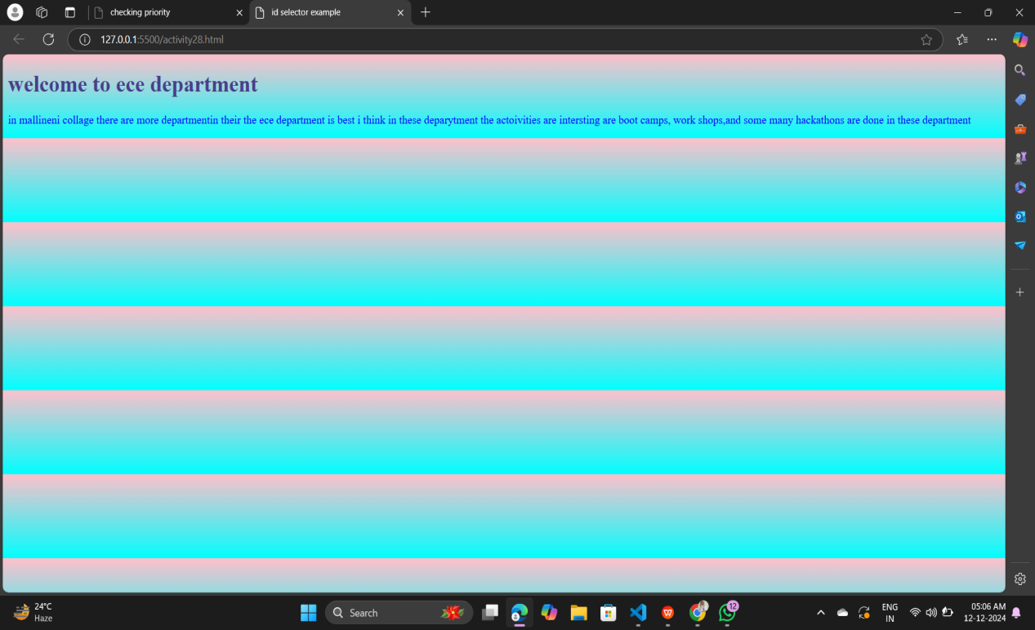

## Description:-

1. Document Structure Tags:
2. <html>: The root element of an HTML document.
3. <head>: Contains meta data and links to external resources (e.g., style sheets, scripts).
4. <body>: Contains the visible content of the page.
5. <title>: Sets the title of the web page (appears in the browser tab).
6. <!DOCTYPE html>: Declares the document type (HTML5)
7. <p>: Paragraph.
8. <h1> : Heading
9. An ID selector is used in CSS to style an element with a specific id attribute. The syntax for an ID selector starts with a # followed by the ID name.
10. The id="main-title" in the HTML associates the h1 element with the ID selector in the CSS.
11. The CSS rule #main-title applies only to the element with the id="main-title".
12. As a result, the heading will be blue, have a font size of 36px, and be centered.

# ACTIVITY-28

## Display the By- Class selector example

## TOOLS USED:-

#### VISUAL STUDIO CODE:

Visual Studio Code (VS Code) is a free, open-source code editor developed by Microsoft. It is widely used for programming and development across various languages and platforms due to its lightweight design, robust features, and extensive customizability.

#### HTML:

Hyper Text Markup Language is a tool to develop website

#### CSS:

CSS (Cascading Style Sheets) is a style sheet language used to control the presentation and layout of HTML documents. It enables you to style elements by applying rules for color, size, spacing, fonts, and more.

## CODE:

<!DOCTYPE html>

<html>

    <head>

        <title>

            class selector example

        </title>

        <style>

            .one{

                color: brown;

            }

            body{

                background-image: linear-gradient(blueviolet,pink);

            }

            .tw0{

                color: brown;

            }

        </style>

    </head>

    <body>

        <h1 class="one">the galaxy</h1>

        <p class="two">in galaxy consist of all space materials like stars planets etc</p>

    </body>

</html>

## OUTPUT:-

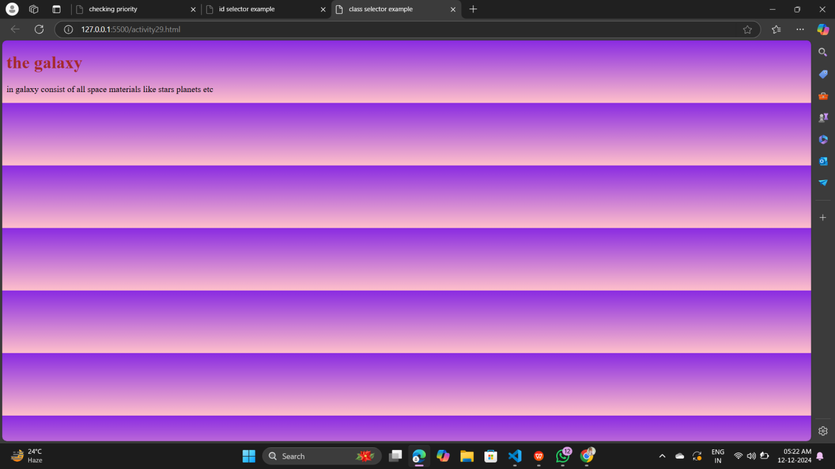

## Description:-

1. Document Structure Tags:
2. <html>: The root element of an HTML document.
3. <head>: Contains meta data and links to external resources (e.g., style sheets, scripts).
4. <body>: Contains the visible content of the page.
5. <title>: Sets the title of the web page (appears in the browser tab).
6. <!DOCTYPE html>: Declares the document type (HTML5)
7. <p>: Paragraph.
8. <h1> : Heading.
9. A class selector is used in CSS to style elements with a specific class attribute. The syntax for a class selector starts with a (.) followed by the class name.

# ACTIVITY-29

## Display the By-Element selector example

## TOOLS USED:-

#### VISUAL STUDIO CODE:

Visual Studio Code (VS Code) is a free, open-source code editor developed by Microsoft. It is widely used for programming and development across various languages and platforms due to its lightweight design, robust features, and extensive customizability.

#### HTML:

Hyper Text Markup Language is a tool to develop website

#### CSS:

CSS (Cascading Style Sheets) is a style sheet language used to control the presentation and layout of HTML documents. It enables you to style elements by applying rules for color, size, spacing, fonts, and more.

## CODE:

<!DOCTYPE html>

<html>

    <head>

        <title>

            by element selector

        </title>

        <style>

            body{

color: crimson;

background-image: linear-gradient(blue,pink);

            }

        </style>

    </head>

    <body>

        <h1>welcome to iot boot camp</h1>

        <p>in these bootcamp we are learnt about the sensor integrated projects</p>

    </body>

</html>

## OUTPUT:-

## 

## Description:-

1. Document Structure Tags:
2. <html>: The root element of an HTML document.
3. <head>: Contains meta data and links to external resources (e.g., style sheets, scripts).
4. <body>: Contains the visible content of the page.
5. <title>: Sets the title of the web page (appears in the browser tab).
6. <!DOCTYPE html>: Declares the document type (HTML5)
7. <p>: Paragraph.
8. <h1> : Heading.
9. In CSS, an element selector targets all elements of a specific type (e.g., all <p> tags, <div> tags, etc.) in the HTML document. Unlike class or ID selectors, element selectors don't require any prefixes.

# ACTIVITY-30

## Display the grouping selector example

## TOOLS USED:-

#### VISUAL STUDIO CODE:

Visual Studio Code (VS Code) is a free, open-source code editor developed by Microsoft. It is widely used for programming and development across various languages and platforms due to its lightweight design, robust features, and extensive customizability.

#### HTML:

Hyper Text Markup Language is a tool to develop website

#### CSS:

CSS (Cascading Style Sheets) is a style sheet language used to control the presentation and layout of HTML documents. It enables you to style elements by applying rules for color, size, spacing, fonts, and more.

## CODE:

<!DOCTYPE html>

<html>

    <head>

        <title>

            grouping selectors example

        </title>

        <style>

            h1,p{

                color: aqua;

                background-color: rgb(196, 17, 190);

                font-size: medium;

                font-style: italic;

            }

        </style>

    </head>

    <body>

        <h1>mallineni lakshmiaha womens engeneering collage</h1>

        <p>Lorem ipsum dolor sit amet, consectetur adipisicing elit. Vero architecto rerum sequi, nemo officia culpa ab, sunt assumenda quasi ea distinctio voluptate. Unde doloremque odit neque quos rem enim dolores?</p>

    </body>

</html>

<!DOCTYPE html>

<html>

    <head>

        <title>

            universal selector example

        </title>

        <style>

            *{

                color: brown;

                background-color: aqua;

            }

        </style>

    </head>

    <body>

        <h1>welcome to our UNIVERSE</h1>

        <p>Lorem ipsum dolor sit amet consectetur adipisicing elit. Aspernatur a sit iusto totam. Laudantium, quidem! Quidem vel deserunt, ipsam blanditiis officiis cupiditate soluta odit fugit quam voluptates doloremque. Neque, totam.</p>

    </body>

</html>

## OUTPUT:-

## Screenshot 2024-12-12 053122

## Description:-

1. Document Structure Tags:
2. <html>: The root element of an HTML document.
3. <head>: Contains meta data and links to external resources (e.g., style sheets, scripts).
4. <body>: Contains the visible content of the page.
5. <title>: Sets the title of the web page (appears in the browser tab).
6. <!DOCTYPE html>: Declares the document type (HTML5)
7. <p>: Paragraph.
8. <h1> : Heading.
9. In CSS, grouping selectors allow you to apply the same styles to multiple selectors. This helps reduce redundancy and keeps your CSS cleaner.
10. Separate selectors with a comma (,) to group them together.

# ACTIVITY-31

## Display the universal selector example

## TOOLS USED:-

#### VISUAL STUDIO CODE:

Visual Studio Code (VS Code) is a free, open-source code editor developed by Microsoft. It is widely used for programming and development across various languages and platforms due to its lightweight design, robust features, and extensive customizability.

#### HTML:

Hyper Text Markup Language is a tool to develop website

#### CSS:

CSS (Cascading Style Sheets) is a style sheet language used to control the presentation and layout of HTML documents. It enables you to style elements by applying rules for color, size, spacing, fonts, and more.

## CODE:

<!DOCTYPE html>

<html>

    <head>

        <title>

            universal selector example

        </title>

        <style>

            *{

                color: brown;

                background-color: aqua;

            }

        </style>

    </head>

    <body>

        <h1>welcome to our UNIVERSE</h1>

        <p>Lorem ipsum dolor sit amet consectetur adipisicing elit. Aspernatur a sit iusto totam. Laudantium, quidem! Quidem vel deserunt, ipsam blanditiis officiis cupiditate soluta odit fugit quam voluptates doloremque. Neque, totam.</p>

    </body>

</html>

## OUTPUT:-

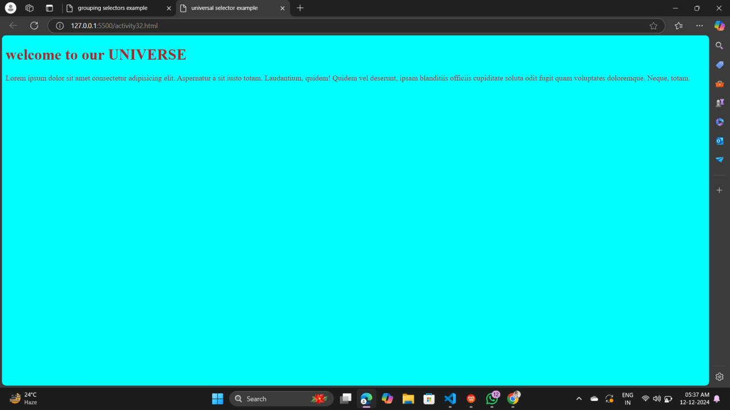

## Description:-

1. Document Structure Tags:
2. <html>: The root element of an HTML document.
3. <head>: Contains meta data and links to external resources (e.g., style sheets, scripts).
4. <body>: Contains the visible content of the page.
5. <title>: Sets the title of the web page (appears in the browser tab).
6. <!DOCTYPE html>: Declares the document type (HTML5)
7. <p>: Paragraph.
8. <h1> : Heading.
9. The universal selector in CSS targets all elements in a document. It is represented by an asterisk (*). This is useful for applying global styles or resetting default browser styles.

# ACTIVITY-32

## Display the BORDER EXAMPLE

## TOOLS USED:-

#### VISUAL STUDIO CODE:

Visual Studio Code (VS Code) is a free, open-source code editor developed by Microsoft. It is widely used for programming and development across various languages and platforms due to its lightweight design, robust features, and extensive customizability.

#### HTML:

Hyper Text Markup Language is a tool to develop website

#### CSS:

CSS (Cascading Style Sheets) is a style sheet language used to control the presentation and layout of HTML documents. It enables you to style elements by applying rules for color, size, spacing, fonts, and more.

## CODE:

<!DOCTYPE html>

<html>

    <head>

        <title>

            boarder EXAMPLE

        </title>

        <style>

            div{

                border-style:groove;

                border-color: blueviolet;

            border-width: 20px;

            }

        </style>

    </head>

    <body>

        <div>

            <p>Here's a more detailed explanation of the features and design considerations for the CareBot:

                Features:

                1. Delivery of essential items: CareBot can transport and deliver food, water, medication, and personal care products to the patient's location, reducing the need for human contact.

                2. Vital sign monitoring: CareBot can be equipped with sensors to monitor the patient's temperature, pulse, oxygen saturation, and blood pressure, providing valuable data for remote healthcare monitoring.

                3. Telemedicine enablement: CareBot can facilitate video conferencing between the patient and healthcare professionals, enabling remote consultations and reducing the need for in-person visits.

                4. Disinfection and cleaning: CareBot can be equipped with UV light or hydrogen peroxide vaporization technology to</p>

        </div>

    </body>

</html>

## OUTPUT:-

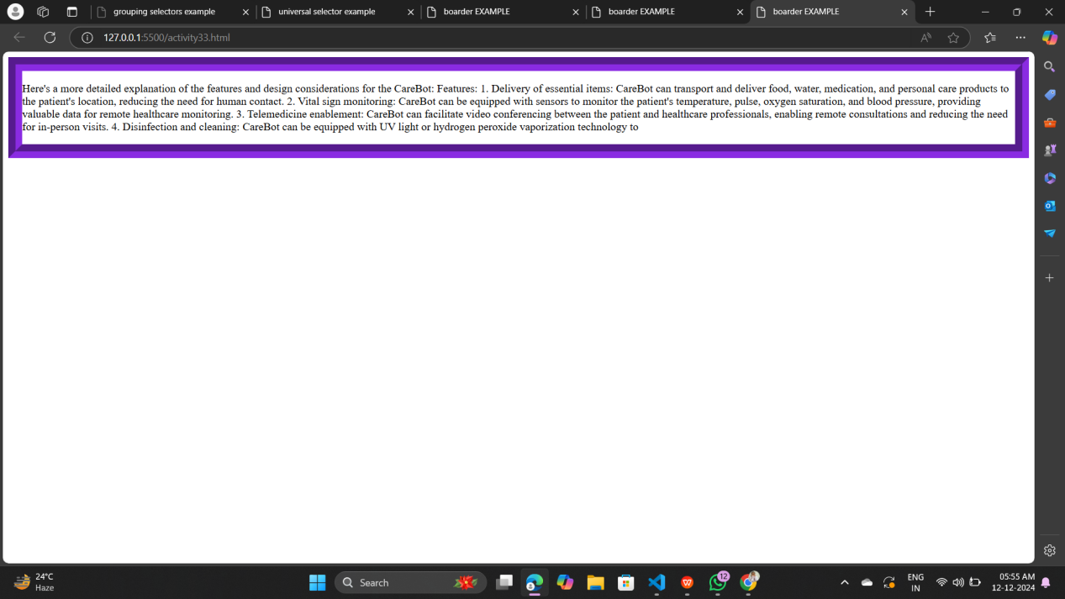

## Description:-

1. Document Structure Tags:
2. <html>: The root element of an HTML document.
3. <head>: Contains meta data and links to external resources (e.g., style sheets, scripts).
4. <body>: Contains the visible content of the page.
5. <title>: Sets the title of the web page (appears in the browser tab).
6. <!DOCTYPE html>: Declares the document type (HTML5)
7. <p>: Paragraph.
8. <h1> : Heading.
9. The border property in CSS is used to define the style, width, and color of an element's border.
10. none: No border.
11. solid: A single solid line.
12. dotted: A series of dots.
13. dashed: A series of dashes.
14. double: Two solid lines.
15. groove: A carved effect.
16. ridge: A ridged effect.
17. inset: Appears embedded.
18. outset: Appears coming out.

# ACTIVITY-33

## Display the BORDER EXAMPLE

## TOOLS USED:-

#### VISUAL STUDIO CODE:

Visual Studio Code (VS Code) is a free, open-source code editor developed by Microsoft. It is widely used for programming and development across various languages and platforms due to its lightweight design, robust features, and extensive customizability.

#### HTML:

Hyper Text Markup Language is a tool to develop website

#### CSS:

CSS (Cascading Style Sheets) is a style sheet language used to control the presentation and layout of HTML documents. It enables you to style elements by applying rules for color, size, spacing, fonts, and more.

## CODE:

<!DOCTYPE html>

<html>

    <head>

        <title>

            boarder EXAMPLE

        </title>

        <style>

            div{

                border-style:dotted;

                border-color: rgb(43, 226, 119);

            border-width: 20px;

            }

        </style>

    </head>

    <body>

        <div>

            <p>Here's a more detailed explanation of the features and design considerations for the CareBot:

                Features:

                1. Delivery of essential items: CareBot can transport and deliver food, water, medication, and personal care products to the patient's location, reducing the need for human contact.

                2. Vital sign monitoring: CareBot can be equipped with sensors to monitor the patient's temperature, pulse, oxygen saturation, and blood pressure, providing valuable data for remote healthcare monitoring.

                3. Telemedicine enablement: CareBot can facilitate video conferencing between the patient and healthcare professionals, enabling remote consultations and reducing the need for in-person visits.

                4. Disinfection and cleaning: CareBot can be equipped with UV light or hydrogen peroxide vaporization technology to</p>

        </div>

    </body>

</html>

## OUTPUT:-

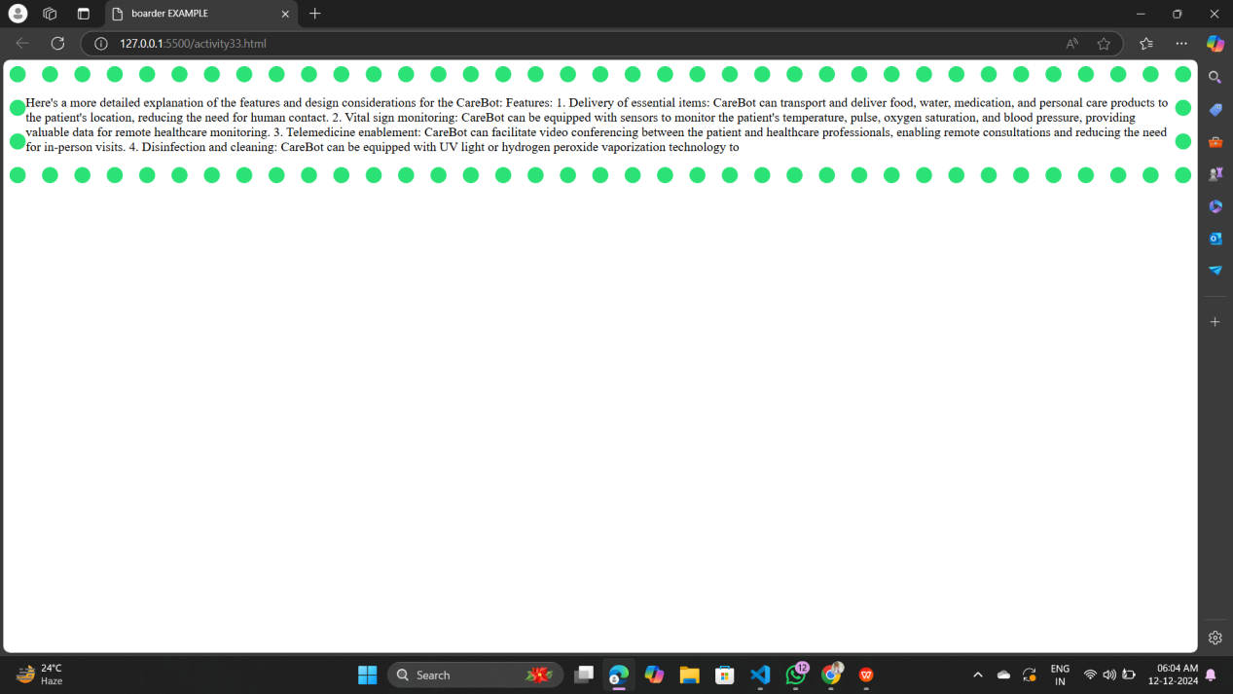

## Description:-

1. Document Structure Tags:
2. <html>: The root element of an HTML document.
3. <head>: Contains meta data and links to external resources (e.g., style sheets, scripts).
4. <body>: Contains the visible content of the page.
5. <title>: Sets the title of the web page (appears in the browser tab).
6. <!DOCTYPE html>: Declares the document type (HTML5)
7. <p>: Paragraph.
8. <h1> : Heading.
9. The border property in CSS is used to define the style, width, and color of an element's border.
10. none: No border.
11. solid: A single solid line.
12. dotted: A series of dots.
13. dashed: A series of dashes.
14. double: Two solid lines.
15. groove: A carved effect.
16. ridge: A ridged effect.
17. inset: Appears embedded.
18. outset: Appears coming out.

# ACTIVITY-34

## Display the BORDER EXAMPLE

## TOOLS USED:-

#### VISUAL STUDIO CODE:

Visual Studio Code (VS Code) is a free, open-source code editor developed by Microsoft. It is widely used for programming and development across various languages and platforms due to its lightweight design, robust features, and extensive customizability.

#### HTML:

Hyper Text Markup Language is a tool to develop website

#### CSS:

CSS (Cascading Style Sheets) is a style sheet language used to control the presentation and layout of HTML documents. It enables you to style elements by applying rules for color, size, spacing, fonts, and more.

## CODE:

<!DOCTYPE html>

<html>

    <head>

        <title>

            boarder EXAMPLE

        </title>

        <style>

            div{

                border-style:groove;

                border-color: rgb(43, 226, 119);

            border-width: 20px;

            border-radius: 50px;

    border-bottom-left-radius: 30px;

    border-bottom-right-radius: 30px;

    border-top-left-radius: 30px;

    border-top-right-radius: 30px;

            }

        </style>

    </head>

    <body>

        <div>

            <p>Here's a more detailed explanation of the features and design considerations for the CareBot:

                Features:

                1. Delivery of essential items: CareBot can transport and deliver food, water, medication, and personal care products to the patient's location, reducing the need for human contact.

                2. Vital sign monitoring: CareBot can be equipped with sensors to monitor the patient's temperature, pulse, oxygen saturation, and blood pressure, providing valuable data for remote healthcare monitoring.

                3. Telemedicine enablement: CareBot can facilitate video conferencing between the patient and healthcare professionals, enabling remote consultations and reducing the need for in-person visits.

                4. Disinfection and cleaning: CareBot can be equipped with UV light or hydrogen peroxide vaporization technology to</p>

        </div>

    </body>

</html>

## OUTPUT:-

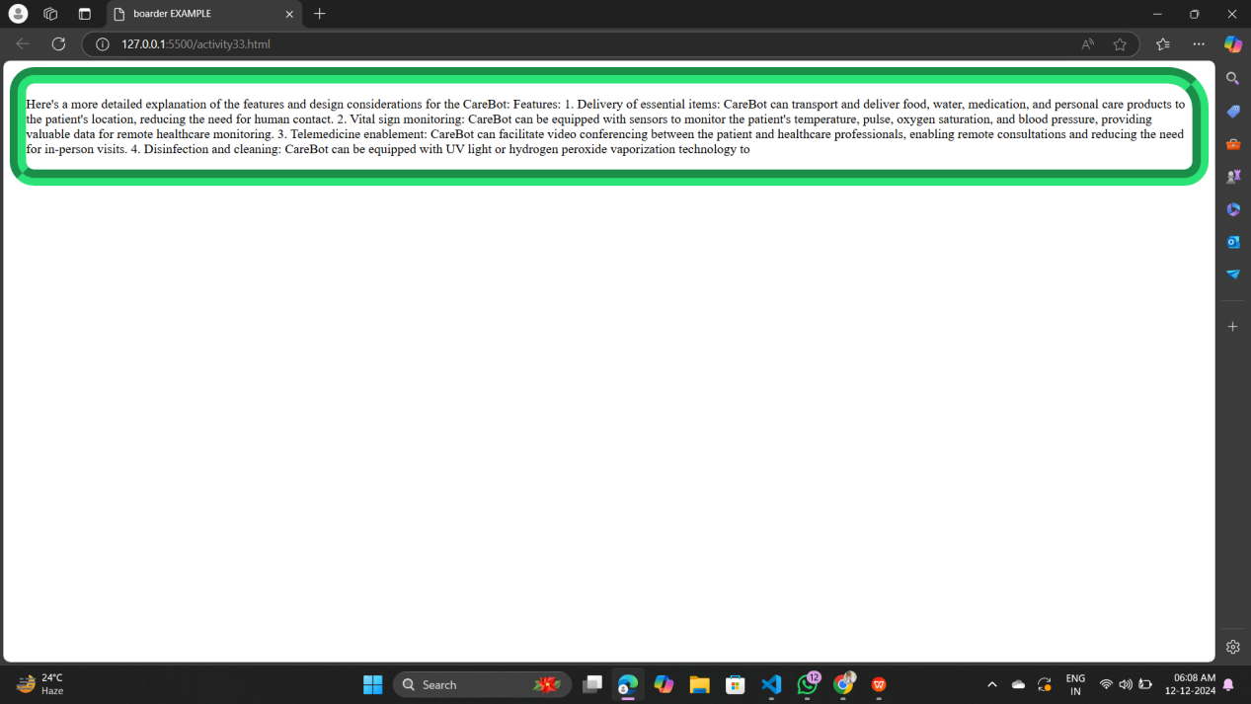

## Description:-

1. Document Structure Tags:
2. <html>: The root element of an HTML document.
3. <head>: Contains meta data and links to external resources (e.g., style sheets, scripts).
4. <body>: Contains the visible content of the page.
5. <title>: Sets the title of the web page (appears in the browser tab).
6. <!DOCTYPE html>: Declares the document type (HTML5)
7. <p>: Paragraph.
8. <h1> : Heading.
9. The border property in CSS is used to define the style, width, and color of an element's border.
10. none: No border.
11. solid: A single solid line.
12. dotted: A series of dots.
13. dashed: A series of dashes.
14. double: Two solid lines.
15. groove: A carved effect.
16. ridge: A ridged effect.
17. inset: Appears embedded.
18. outset: Appears coming out.
19. The border-radius property in CSS is used to create rounded corners for elements. You can apply it to all corners uniformly or to specific corners individually.
20. value: Can be a length (e.g., px, em) or a percentage (%).

# ACTIVITY-35

## Display the IMAGE BORDER EXAMPLE

## TOOLS USED:-

#### VISUAL STUDIO CODE:

Visual Studio Code (VS Code) is a free, open-source code editor developed by Microsoft. It is widely used for programming and development across various languages and platforms due to its lightweight design, robust features, and extensive customizability.

#### HTML:

Hyper Text Markup Language is a tool to develop website

#### CSS:

CSS (Cascading Style Sheets) is a style sheet language used to control the presentation and layout of HTML documents. It enables you to style elements by applying rules for color, size, spacing, fonts, and more.

## CODE:

<!DOCTYPE html>

<html>

    <head>

        <title>

            profile

        </title>

        <style>

            img{

                border-radius: 70%;

            }

        </style>

    </head>

    <body>

        <img src="https://t4.ftcdn.net/jpg/05/54/52/13/360_F_554521329_ngmDQSjSrUSRnbK2xK0bkcprsinG9Xdv.jpg" height="500px" width="500px">

    </body>

</html>

## OUTPUT:-

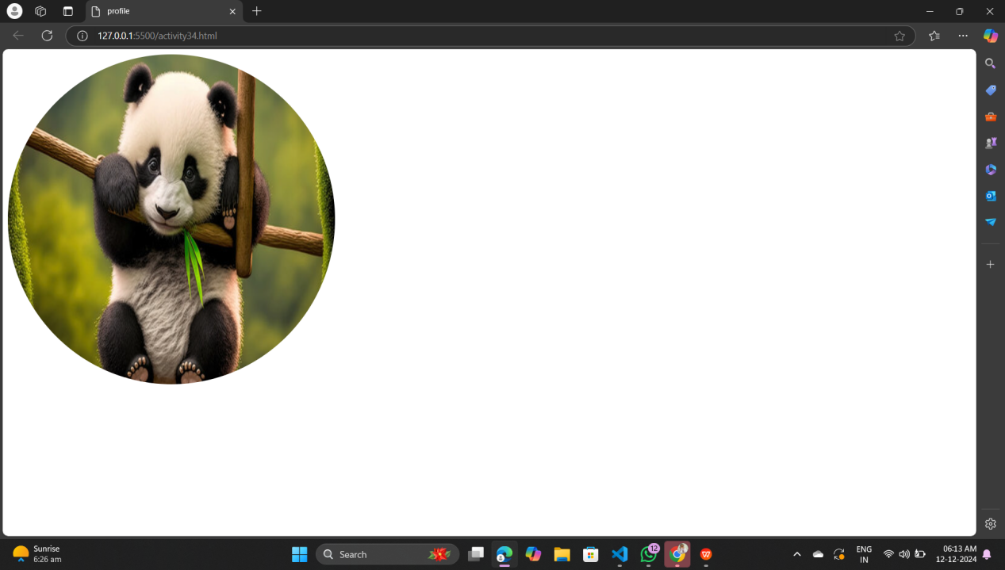

## Description:-

1. Document Structure Tags:
2. <html>: The root element of an HTML document.
3. <head>: Contains meta data and links to external resources (e.g., style sheets, scripts).
4. <body>: Contains the visible content of the page.
5. <title>: Sets the title of the web page (appears in the browser tab).
6. <!DOCTYPE html>: Declares the document type (HTML5)
7. <p>: Paragraph.
8. <h1> : Heading.
9. Boarder radious-value: Can be a length (e.g., px, em) or a percentage (%).
10. the border and border-radius properties. This allows you to add solid, dashed, or decorative borders, and even create rounded or circular image frames.

# ACTIVITY-36

## Display the three IMAGE BORDER EXAMPLE in between three horizontal rule

## TOOLS USED:-

#### VISUAL STUDIO CODE:

Visual Studio Code (VS Code) is a free, open-source code editor developed by Microsoft. It is widely used for programming and development across various languages and platforms due to its lightweight design, robust features, and extensive customizability.

#### HTML:

Hyper Text Markup Language is a tool to develop website

#### CSS:

CSS (Cascading Style Sheets) is a style sheet language used to control the presentation and layout of HTML documents. It enables you to style elements by applying rules for color, size, spacing, fonts, and more.

## CODE:

!DOCTYPE html>>

<Html>

    <head>

        <title>

            image Description border example

        </title>

        <style>

            img{

                border-radius: 50%;

            }

            #one{

                display: flex;

                align-items: center;

            }

            #two{

                display: flex;

                align-items: center;

            }

            #three{

                display: flex;

                align-items: center;

            }

        </style>

    </head>

    <body >

        <div  id="one">

            <img src="https://t3.ftcdn.net/jpg/06/08/56/08/360_F_608560884_HBJ9yBr6zgod8lEsCr9wku4LE9OgMR35.jpg" height="200px" width="200px">

            <p>The lotus is a symbolically and culturally significant flower with a range of meanings in different traditions, as well as a striking plant admired for its beauty and unique properties.

</p>

        </div>

        <hr>

        <div id="two">

            <img src="https://encrypted-tbn0.gstatic.com/images?q=tbn:ANd9GcSDsl38R7DYmvCxm5v5m-0v6acNGOap4VpDlQ&s" height="200px" width="200px">

            <p>The rose is one of the most iconic and beloved flowers, admired for its beauty, fragrance, and cultural significance across the world.</p>

        </div>

        <hr>

        <div id="three">

            <img src="https://media.istockphoto.com/id/105813631/photo/white-lilies-in-a-garden.jpg?s=612x612&w=0&k=20&c=SBfeASSnl7yhZMoi-WShzk3KBT2XBV_iVnW3GfTW5RM=" height="200px" width="200px">

            <p>The lily is a graceful and elegant flower, celebrated for its beauty, fragrance, and symbolic significance across various cultures and traditions.

            </p>

        </div>

<hr>

    </body>

</Html>

## OUTPUT:-

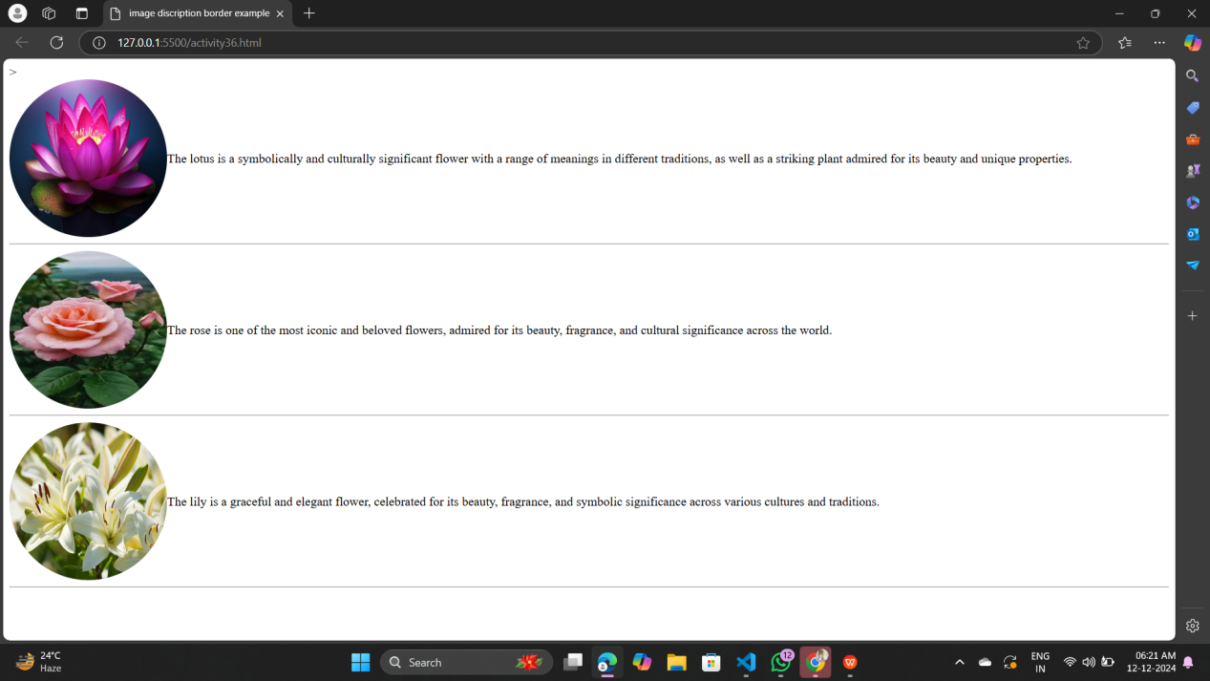

## Description:-

1. Document Structure Tags:
2. <html>: The root element of an HTML document.
3. <head>: Contains meta data and links to external resources (e.g., style sheets, scripts).
4. <body>: Contains the visible content of the page.
5. <title>: Sets the title of the web page (appears in the browser tab).
6. <!DOCTYPE html>: Declares the document type (HTML5)
7. <p>: Paragraph.
8. <h1> : Heading.
9. To create a border around an image with a Description (caption), you can use CSS to style both the image
10. The <div> tag is a container used to group content for styling or layout purposes.
11. The id attribute uniquely identifies an HTML element.
12. It must be unique within the document.
13. The <hr> tag creates a horizontal line, often used to separate content.
14. It's a self-closing tag, meaning it doesn't need a closing </hr>.

# ACTIVITY-37

## Display the margin example

## TOOLS USED:-

#### VISUAL STUDIO CODE:

Visual Studio Code (VS Code) is a free, open-source code editor developed by Microsoft. It is widely used for programming and development across various languages and platforms due to its lightweight design, robust features, and extensive customizability.

#### HTML:

Hyper Text Markup Language is a tool to develop website

#### CSS:

CSS (Cascading Style Sheets) is a style sheet language used to control the presentation and layout of HTML documents. It enables you to style elements by applying rules for color, size, spacing, fonts, and more.

## CODE:

<!DOCTYPE html>

<html>

    <head>

        <title>

            border and margine

        </title>

        <style>

            #one{

                border: 10px solid rgb(23, 23, 24);

                margin: 100px 50px 150px 200px ;

                margin-top: 100px;

                margin-bottom: 100px;

                margin-left: 100px;

                margin-right: 50px;

                /* margin: 200px; */

            }

        </style>

    </head>

    <body>

        <div id="one">

            <p>Lorem ipsum dolor sit amet consectetur adipisicing elit. Quos voluptatem enim dolor in distinctio ex soluta incidunt nulla voluptas culpa eius placeat, inventore ab aspernatur! Amet quidem quos at. A!</p>

        </div>

        <div id="one">

            <p>Lorem, ipsum dolor sit amet consectetur adipisicing elit. Nam exercitationem quidem optio corrupti? Modi libero soluta voluptas, ipsa odit eaque maxime inventore qui quidem illo ducimus facere natus nesciunt magnam?</p>

        </div>

    </body>

</html>

## OUTPUT:-

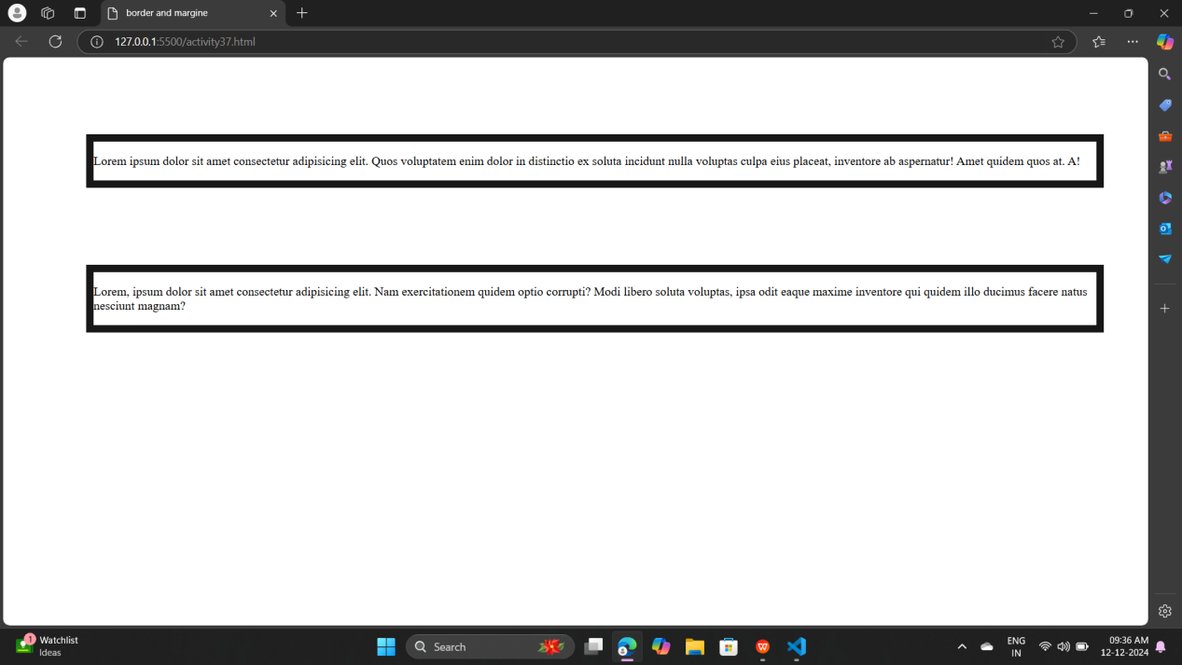

## Description:-

1. Document Structure Tags:
2. <html>: The root element of an HTML document.
3. <head>: Contains meta data and links to external resources (e.g., style sheets, scripts).
4. <body>: Contains the visible content of the page.
5. <title>: Sets the title of the web page (appears in the browser tab).
6. <!DOCTYPE html>: Declares the document type (HTML5)
7. <p>: Paragraph.
8. <h1> : Heading.
9. The margin property in CSS is used to create space around elements, outside of their borders. Margins are used to control the spacing between elements in a layout.
10. You can also specify margins for each side individually:
11. margin-top
12. margin-right
13. margin-bottom
14. margin-left

# ACTIVITY-38

## Display the padding example

## TOOLS USED:-

#### VISUAL STUDIO CODE:

Visual Studio Code (VS Code) is a free, open-source code editor developed by Microsoft. It is widely used for programming and development across various languages and platforms due to its lightweight design, robust features, and extensive customizability.

#### HTML:

Hyper Text Markup Language is a tool to develop website

#### CSS:

CSS (Cascading Style Sheets) is a style sheet language used to control the presentation and layout of HTML documents. It enables you to style elements by applying rules for color, size, spacing, fonts, and more.

## CODE:

<!DOCTYPE html>

<html>

    <head>

        <title>

            padding

        </title>

        <style>

        #one{

            border: 10px solid black;

            margin: 100px;

            padding: 100px;

        }

        </style>

    </head>

    <body>

        <div id="one">

            <p>Lorem ipsum dolor sit amet consectetur, adipisicing elit. Eius iste nisi sit molestias laborum pariatur, fuga aut laboriosam, voluptate voluptas deserunt nulla repellendus sed saepe. Aliquid voluptatibus ab suscipit nobis.</p>

        </div>

        <div id="one"> Lorem ipsum, dolor sit amet consectetur adipisicing elit. Ullam quis recusandae doloribus nulla nobis deleniti voluptatibus, quod culpa, dolor harum mollitia atque odio accusamus reiciendis temporibus tempora tempore animi. Quibusdam?</div>

    </body>

</html>

## OUTPUT:-

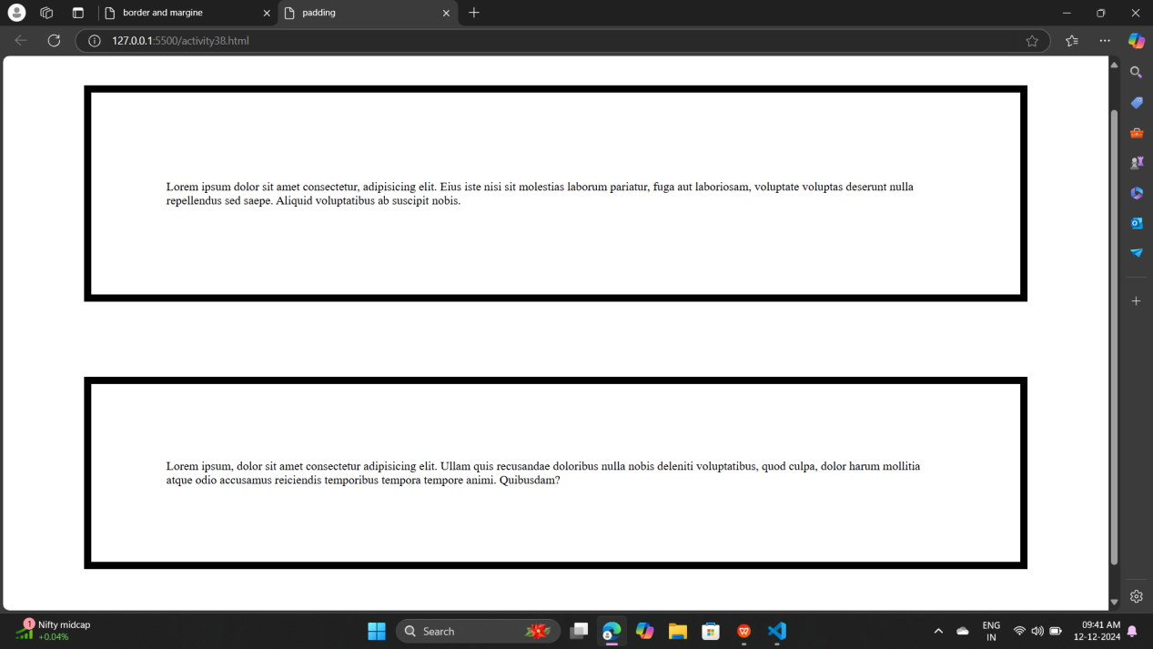

## Description:-

1. Document Structure Tags:
2. <html>: The root element of an HTML document.
3. <head>: Contains meta data and links to external resources (e.g., style sheets, scripts).
4. <body>: Contains the visible content of the page.
5. <title>: Sets the title of the web page (appears in the browser tab).
6. <!DOCTYPE html>: Declares the document type (HTML5)
7. <p>: Paragraph.
8. <h1> : Heading.
9. The padding property in CSS is used to create space between the content of an element and its border. It controls the inner spacing of the element.
10. You can also specify padding for each side individually:
11. padding-top
12. padding-right
13. padding-bottom
14. padding-left

# ACTIVITY-39

## Display the button example

## TOOLS USED:-

#### VISUAL STUDIO CODE:

Visual Studio Code (VS Code) is a free, open-source code editor developed by Microsoft. It is widely used for programming and development across various languages and platforms due to its lightweight design, robust features, and extensive customizability.

#### HTML:

Hyper Text Markup Language is a tool to develop website

#### CSS:

CSS (Cascading Style Sheets) is a style sheet language used to control the presentation and layout of HTML documents. It enables you to style elements by applying rules for color, size, spacing, fonts, and more.

## CODE:

<!DOCTYPE html>

<html>

    <head>

        <title>

            button example

        </title>

        <style>

            button{

                background-color: blueviolet;

                border-radius: 40%;

            }

            button:hover{

                background-color: red;

            }

        </style>

    </head>

    <body>

        <button type="submit">click here</button>

    </body>

</html>

## OUTPUT:-

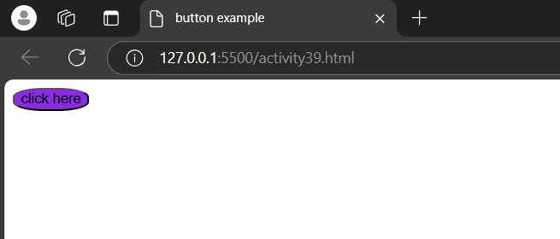

## Description:-

1. Document Structure Tags:
2. <html>: The root element of an HTML document.
3. <head>: Contains meta data and links to external resources (e.g., style sheets, scripts).
4. <body>: Contains the visible content of the page.
5. <title>: Sets the title of the web page (appears in the browser tab).
6. <!DOCTYPE html>: Declares the document type (HTML5)
7. <p>: Paragraph.
8. <h1> : Heading.
9. This creates a basic button using the <button> tag.
10. Basic Styling: The padding, font-size, and border-radius properties determine the size and shape of the button.
11. Hover Effects: Using the :hover pseudo-class and transition, you can create smooth color changes and animations.
12. Icons: The flex property helps align icons and text inside the button.
13. Disabled State: Buttons with disabled attribute can be styled to indicate they are inactive.

# ACTIVITY-40

## Display the button example

## TOOLS USED:-

#### VISUAL STUDIO CODE:

Visual Studio Code (VS Code) is a free, open-source code editor developed by Microsoft. It is widely used for programming and development across various languages and platforms due to its lightweight design, robust features, and extensive customizability.

#### HTML:

Hyper Text Markup Language is a tool to develop website

#### CSS:

CSS (Cascading Style Sheets) is a style sheet language used to control the presentation and layout of HTML documents. It enables you to style elements by applying rules for color, size, spacing, fonts, and more.

## CODE:

<!DOCTYPE html>

<html>

    <head>

        <title>

            button

        </title>

        <style>

            button{

                background-color: aqua;

                border-radius: 50% ;

                margin-top: 300px;

                margin-bottom: 300px;

                margin-left: 700px;

                margin-right: 700px;

            }

            button:hover{

                background-color:brown;

            }

        </style>

    </head>

    <body>

        <button type="submit">click here</button>

    </body>

</html>

## OUTPUT:-

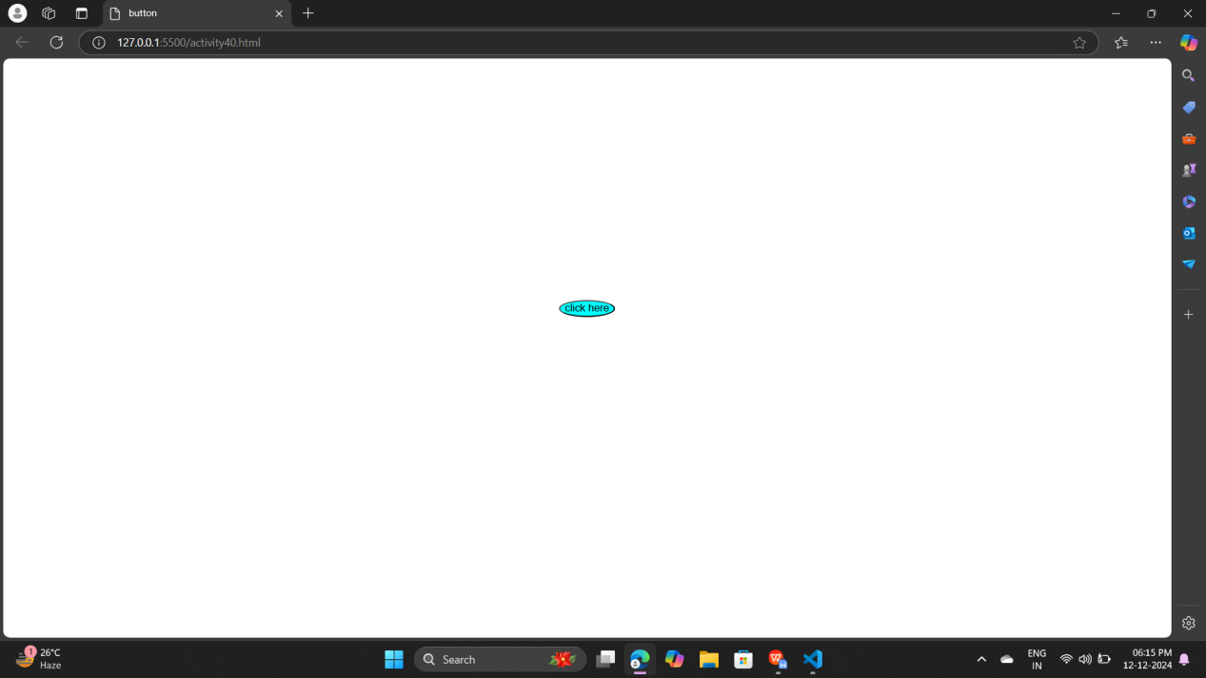

## Description:-

1. Document Structure Tags:
2. <html>: The root element of an HTML document.
3. <head>: Contains meta data and links to external resources (e.g., style sheets, scripts).
4. <body>: Contains the visible content of the page.
5. <title>: Sets the title of the web page (appears in the browser tab).
6. <!DOCTYPE html>: Declares the document type (HTML5)
7. <p>: Paragraph.
8. <h1> : Heading.
9. This creates a basic button using the <button> tag.
10. Basic Styling: The padding, font-size, and border-radius properties determine the size and shape of the button.
11. Hover Effects: Using the :hover pseudo-class and transition, you can create smooth color changes and animations.
12. Icons: The flex property helps align icons and text inside the button.
13. Disabled State: Buttons with disabled attribute can be styled to indicate they are inactive.

